

August 3, 2006 Issue 6
The eMARS Newsletter will be used to disseminate information to agency users on key topics associated with the system.
Inside This Edition
eMARS Training Materials Just a Mouse Click Away 1
Things to Remember When Contacting the Customer Resource Center (CRC) 1
Internet Explorer 1
Communicating Information Vendors Need to Record Our Payments 2
Changing Disbursement Format and Category 2
Cash Inquiries in eMARS 3
Looking Up Payment Information in eMARS 3
User Maintenance Document (UDOC) Workflow Activated (Attention AILs and Security Officers) 5
Tips for Updating UDOCs 5
Approving Documents in eMARS 6
Rejecting Documents in eMARS 7
Checking the Status of Matching Purchase Requests Documents (PRMs and PRMIs) 8
eMARS Terms and Conditions
Dos and Don’ts 8
Manual Draws 9

Check out the
eMARS Web site @ http://finance.ky.gov/internal/emars/


eMARS Training Materials Just a Mouse Click Away

Do you need an eMARS refresher course? If so, visit the eMARS Web site @ http://finance.ky.gov/internal/eMARS/ where you will find that training is just a mouse click away. Once on this Web site you may view on-line training manuals; go through Independent Study Guides (ISGs); or Elluminate recordings that are all self-paced.

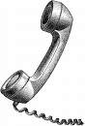
Things to Remember When Contacting the Customer Resource Center (CRC)

With the implementation of any new system, helpdesk call volumes and e-mail requests are certain to increase. The CRC is no exception to this and has added additional resources to assist with the influx of calls and emails. However, users still may encounter a longer hold time when contacting the CRC to reach a helpdesk analyst. As users become familiar with the system, their questions become more in depth and may require additional time and research resulting in longer calls. We ask for your continued patience during this transition time as we all work toward learning the functionality of eMARS.

Remember to frequently visit the News and Alerts link on the eMARS Web site to view any notices of system related alerts.


Internet Explorer

Although MicrosoftTM has released a new (beta) version of Internet ExplorerTM (7.0), that new release is not yet certified for eMARS. The only version of Internet Explorer certified for eMARS is Version 6.0. Do not upgrade to Internet Explorer 7.0 until you receive our recommendation to do so.


Communicating Information Vendors Need to Record Our Payments
When creating payment documents in eMARS agencies should ensure that the Vendor Information and Check Description fields are completed with information that will assist the vendors in identifying how to apply the payment to their accounts. The Vendor Invoice Number and Check Description fields will print out on the check stub. The Check Description field may be found in the Accounting section within the payment document. Up to 24 characters in the Check Description field and all 30 in the Vendor Invoice Number field will print on the check remittance. Please note that any spaces and line returns are counted as characters as well. Only enter text in these fields without adding line returns.

Changing Disbursement Format and Category

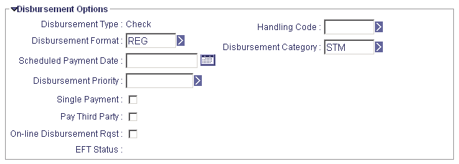
In eMARS, the Disbursement Format code on payment request documents determines the type of payment (check or EFT) and the format of the disbursement. The Disbursement Format code is initially inferred on the payment request document from the vendor's record on the Vendor Customer table in eMARS. To request payment in the form of a check for a vendor that normally receives EFTs, you must change the Disbursement Format code in the Disbursement Options section of the payment request document to 'REG' for regular check format.

In eMARS, the Disbursement Category code on payment request documents determines the method of distribution for checks. For example, a payment request document with the Disbursement Category code of 'STM' would be sealed and mailed by Treasury while a Disbursement Category of 'UAM' would be unsealed and sent back to the agency to be mailed. The Disbursement Category code resides on both the Vendor lines as well as on the accounting lines of payment request documents (this is also true on the Travel Payment (TP) document, although it is not displayed on the accounting lines). When an accounting line is created on a payment request document, it infers the Disbursement Category code from the value on the vendor line.

PLEASE NOTE: Changing the Disbursement Category code on the vendor line of payment request documents AFTER some accounting lines have been created will result in multiple disbursements for the same vendor (one for each Disbursement Category used). To avoid this, ONLY one Disbursement Category code should be used per payment request document. Therefore, set the appropriate Disbursement Category code on the vendor line PRIOR to entering ANY accounting lines on the payment request document to ensure they are consistent. On TP documents, if some accounting lines already exist and you need to change the Disbursement Category code, first delete the existing accounting lines, change the Disbursement Category code and then re-enter the accounting lines.

Cash Inquiries in eMARS

There are a number of ways to access cash detail information within eMARS. To learn more about this topic, please refer to the Cash Inquiries in eMARS document located on the eMARS Web site @ http://finance.ky.gov/internal/eMARS/ under the A.I.L. Documentation/ Financial link. Topics covered in this document include:
- Cash Balance Inquiry Screen;

- Budgetary Cash Detail Lookups; and
- Info Advantage Reporting.

Looking Up Payment Information in eMARS

To see what payments have been made to a vendor:

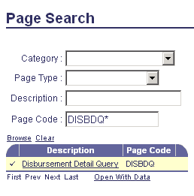
- Go to Page Search.

- Type DISBDQ in the Page Code field and click Browse.

- Click on the hyper link for Disbursement Detail Query (page should open).

- Go to Vendor Code field and click the drop down arrow to the right of the field.

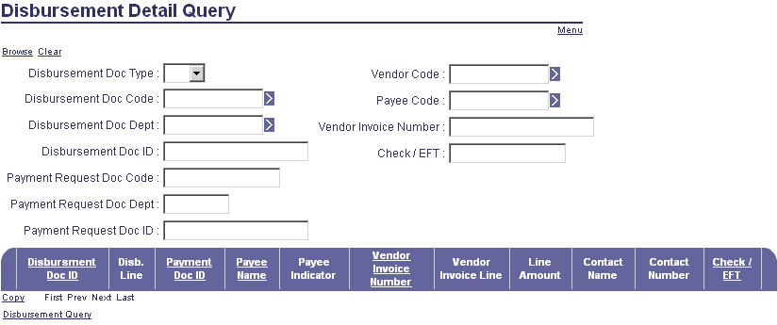

- Type in info to find vendor (either Legal Name or Vendor Code). Click Browse.

- Select the vendor (this will return you to the DISBDQ table).

- Click Browse.

- This should bring up any payments made to this vendor. You may click on the Document ID to go to the document that created the payment.

To see if a check has cleared:

- Go to Page Search.

- Type DISBDQ in the Page Code field and click Browse.

- Click on the hyper link for Disbursement Detail Query (page should open).

- Complete the following fields
- Payment Request Doc CODE;
- Payment Request Doc Dept ID; and
- Payment Request DOC ID.

- Click Browse. Note: This should bring up all the document lines. The Check/EFT number is located in the last field on the right side of this screen.

- Record the check number for the line you need to research.

- Go to the Page Search.

- Type CHREC in the Page Code field and click Browse.

- Click on the hyper link for Check Reconciliation link (page should open).

- Click on Search.

- Enter Bank Code (G1).

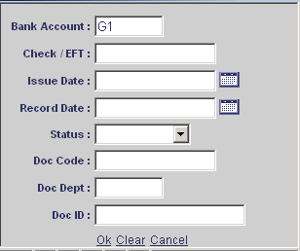
- Enter the Check/EFT number (Note: Use a preceding * and last four-five digits of number).

- Press Enter. This should bring up your Check/EFT number and the status, if it has not been cashed by the recipient. If the Check/EFT is not found perform similar steps on table PDCHK to see the date the Check/EFT cleared the bank.

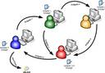
User Maintenance Document (UDOC) Workflow Activated (Attention AILs and Security Officers)

During the implementation process, the eMARS project team worked with the agencies to identify the types of security and approval/workflow roles that should be assigned to each user. In an effort to assist the agencies with the potential influx of security requests leading up to and beyond the eMARS Go Live date your security officers were granted authority to submit the UDOC documents to FINAL status. Now that the majority of user security has been established, the Office of the Controller has activated a workflow rule for all UDOCs, which will result in all UDOCs being routed to Statewide Accounting Services (SAS) for approval and final submission. This means that once your agency security office clicks Submit their UDOCs will now be electronically routed to the Statewide Accounting Central Worklist, instead of an agency Worklist for approval and final submission. In addition, agency approval for UDOCs has been deactivated. However, if your agency wishes to activate agency-level approvals on UDOCs, they may do so by sending an e-mail request from your AIL and/or Security Officer to Donald Sweasy and Jill Williams.

This security change should not be confused with the UDOC workflow rules that were gathered during the agency implementation process. UDOC rules collected during this process have been loaded into eMARS along with the other approval/workflow information, which is currently being utilized by your agencies. Only the agency approval for UDOCs has been deactivated.


Tips for Updating UDOCs

When updating a user’s security on a UDOC, it is STRONGLY RECOMMENDED that a NEW document be created and the Populate From Existing User link is used to bring in the user’s information (i.e. personal info, security roles, workflow roles) to populate the document. By doing this a complete picture of the user’s current security will be provided. This makes it easy for the security officer to determine the type of security a user currently has and identify any roles the user may need that are not part of their current security profile.

Once the new document is created, the security officer may elect to add additional roles by clicking on the Insert New Line link.

When modifying roles currently assigned to a user you cannot simply type over the existing role and leave the precedence the same.

For example, assume you initially granted a user create access to a GAX (Role ID of GAX_C_H). You should have granted the user create/approve access instead (Role ID of GAX_A_H). Now you need to correct this error and modify the user’s security.

When you generate a NEW document by using the Populate Form Existing User this enables you to see the security roles currently assigned to the individual. For instance, let’s say our user currently has the following roles.

Role ID | Precedence
INTERNAL | 1
BUDG_INQ | 2
PROC_INQ | 3
VEND_INQ | 4
GAX_C_H | 5

In our example, you would need to leave the GAX_C_H with Precedence 5 as is and simply click the radio button beside the DELETE action for that role. You would then add a new role (number 6) for the GAX_A_H role and mark the radio button beside it to indicate ADD. When the document is processed, role 5 will be deleted and role 6 will be added.

Caution: If you attempt to submit a UDOC modification where you typed over an existing Role ID, it will generate a Unique Constraint error.

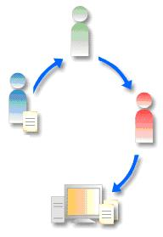
Approving Documents in eMARS
For those end-users who have security to apply approvals, the following provides you with step-by-step instructions on how to log into eMARS, located documents awaiting approval and apply the needed approval.

- Take the Intro to eMARS Independent Study Guide (ISG) located @
http://finance.ky.gov/internal/eMARS/training.htm. Pay attention to the section on
Workflow and Approvals.

- Log into eMARS at https://emars.ky.gov/.

- Type in your User ID and Password then click Login.

Note: If it is your first time logging into eMARS you will be prompted to change your password. Password must have at least one number, one capital letter and one special character such as @#$.)
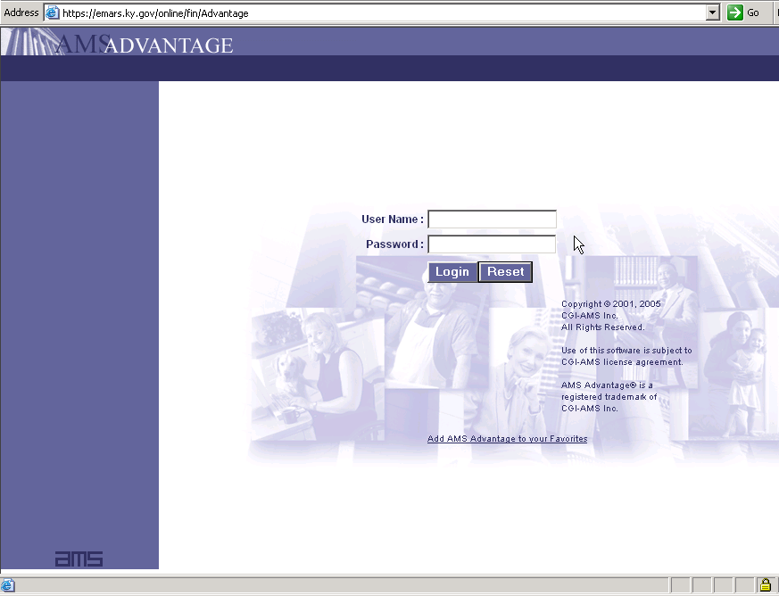

- Go to Secondary Navigation panel (left side of screen) and click on Message Center.

- Click on the Worklist link.
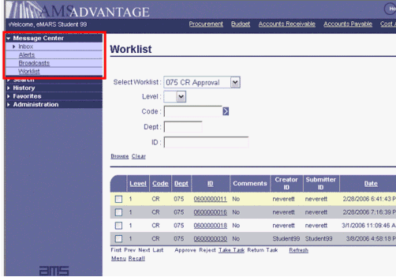

- Change the Worklist from your name to the desired approval group by clicking the drop down arrow to the right of the field.

- Screen should open with documents listed to be approved.

- Click in the check box next to each document (you can click all of the boxes showing at one time).

- Go to the bottom of the list and click on Take Task.

- Continue doing this until you have selected all the documents you want to approve.

- Go back to the top of the page where you selected your approval group and click on the dropdown arrow again and select your name.

- Click on the Document ID to open the document and review the content prior to applying your approval.

- Click on the Action Menu and select Approve after you have reviewed the content and are ready to apply approval.

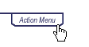
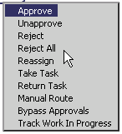
Rejecting Documents in eMARS

If a document has been routed to you for approval and you want to reject the document, you have two options. Reject or Reject All.

Reject – This action is used to indicate that you do not want to approve the currently assigned approval level on the selected document. The document will then be routed back to the approver that previously approved the document. The document could also be routed back to the Draft phase if this is the first approval routing. A Reject action may be applied at any approval level and by any approver, as opposed to Unapprove, which may only be applied on a document on which a Reject action has been applied. This action will not allow the previous approver to make any changes to the document.

Reject All – This action is used to indicate that you do not want to approve the currently assigned approval level on the selected document and want to remove the document from approval processing. Applying this action will reject your and all other approval levels and will route the document back to the document catalog for corrections. The Reject All action may be applied from inside the document if you have accessed the document from your Worklist or from the Worklist directly.

One other thing to remember is that if a document has errors or warnings when the final approval is applied, the system will automatically perform a Reject All action on the document and return the document to Draft status. For example, if the user who entered the document entered a Record Date in the header of the document and that date has passed by the time the final approval is applied, the document will be rejected back to a Draft status.

IMPORTANT: When rejecting documents, please remember to insert a comment using the Document Comment link located on the Secondary Navigation menu and enter text that will assist in determining why the document was rejected.


Checking the Status of Matching Purchase Requests Documents (PRMs and PRMIs)
When paying bills through two-way and three-way matching, remember to check the Matching Status (MATA) Table to ensure your PRM or PRMI was generate properly. PRM/PRMI documents are created during the nightly cycle provided all matching criteria are met. These documents will submit to a FINAL status if no errors are present. On occasion, the PRM/PRMI documents will reject with errors.

When PRM/PRMI documents reject during the nightly cycle, the matching process is not complete. Therefore, if the rejected document is not addressed, another PRM/PRMI document will be generated during the next nightly cycle and replace the previous PRM/PRMI. This process will continue until the department addresses the errors. It is the department’s responsibility to check for rejected PRM/PRMI documents daily on the Document Catalog.

For more information on matching payments, please refer to the 1320 Accounts Payable manual on the eMARS Website @ http://finance.ky.gov/internal/eMARS/manuals.htm.


Dos
and
Don'ts

eMARS Terms and Conditions Dos and Don’ts
The following information is intended to assist you when creating Terms and Conditions (T&Cs) in eMARS. Additional information regarding T&Cs may be found in the eMARS 602 Advanced Procurement manual located on the eMARS Web site @ http://finance.ky.gov/internal/eMARS/manuals.htm.

Things you should do when creating T&Cs:
- Set the top margin of your Word Document to 1.5
- Save the document as an xml file.
- Add supporting documents when necessary. These documents must also be in xml format, but they will appear below the T&Cs when the document is assembled. If multiple attachments are used, there will be a page break between each attachment.
- If you insert a line accidentally delete it using the scissors icon.
- Use Normal formatting for all text.
- Use Grid formatting for all tables.
- Clear all formatting and then reformat your bolding, bullets and justifications if using an existing document for the first time.
- Select the Free T&C, then delete the attached file and upload your xml document. If you have inserted a link to a picture(s) in your document, you must upload the picture file(s) after you have uploaded the xml file.
- Attach any type of document, regardless of file type, in the Header section.

Things you should not do when creating T&Cs:
- Do not use Section breaks – the assembly process stops at the first section break.
- Do not use Page breaks – these are ignored in the assembly process.
- Do not use Track Changes.
- Do not add T&Cs to the Commodity T&Cs section – add them to the Terms and Conditions section only.
- Do not insert blank lines in the Supporting Documents section.
- Do not insert objects directly into the document.
Note: If you have a picture, you must insert as a link to the file. Attach any documents as Supporting Documents or in the document Header section.


Manual Draws

The eMARS Grants Frequently Asked Questions document provided on the eMARS Web site @ http://finance.ky.gov/internal/eMARS/Cost+Accounting.htm states that 100 percent Federal Program-Funding Profile combination must be set up to record manually created Cash Receipt documents that post drawdowns against a program that splits between funds. That is a lot of setup. Isn’t there a more efficient way?

There are at least a couple of other ways, but they will require more diligence on your part. You will have to judge whether they are more efficient.

One way is to let the transaction split according to the same percentages as are applied to reimbursable transactions. Depending on the documents you create (Receivable and Cash Receipt that references the Receivable or just Cash Receipt), you would end up with the following Federal balances posted to the state fund at the state share percentage: open receivable (Earned, Uncollected Revenue), Revenue and Cash. It is your responsibility to monitor the system for balances such as these and use the JVC document to restate them to the Federal Fund, and Federal Funding Line of the applicable Funding Profile and Priority. Note that it is recommended that you create only the Cash Receipt document to record a manual draw; the Receivable document is not necessary.

There is a second way that would result in all Federal transaction activity posting initially, and properly, to the Federal Fund. This option would include setting up one Major Program Structure (MPS) to be used as a clearing structure for manually created drawdowns (reimbursements or advance funding). That structure would have one Funding Profile that is 100 percent Federal. You would code all of your manually-created Cash Receipt documents to this structure. (To repeat, no Receivable Document is necessary.) After you record your cash receipt, you would prepare a JVC document to restate the revenue and cash to reflect the applicable Program, Program Period, Funding Profile, Priority and Line. It would be your responsibility to see that these restatements are recorded. Note that if you are in the Drawdown Department in situations where a number of other departments participate in your grants, it could be very cumbersome for you to monitor the others to make sure that they are correctly distributing the revenue and cash that you draw on their behalf.


For more information on eMARS, please refer to the Frequently Asked Questions document on the eMARS Web site @ http://finance.ky.gov/internal/emars/

