

eMARS Newsletter
May 26, 2010 Issue 30

The eMARS Newsletter is used to disseminate information to agency users on key topics associated with the system.
Inside This Edition
IMPORTANT! – eMARS Year-End
System Availability Schedule 1
Year-End Close and New Year Changes Frequently Asked Questions 1
Completing Payment Documents During Period 13 3
Matching Payments During Period 13 4
Budget Fiscal Year (BFY) 2010
Pending Transactions 4
Fiscal Year (FY) 2010/2011 Encumbrance Roll/Lapse 4
Payments Against Lapsed Awards 4
Moving Expenditures Between Fiscal Years 5
Closing Schedule Clarification 6
EO1 Process for PSCS, MOAs, and Grants 6
Fixed Assets Update 7
Report Redevelopment Tips 7
Payment Correction 8
Reminder -- Use Appropriate Object Codes 10
New Year Table Initialization (NYTI) Process 10
eMARS Training Hiatus 10

Check out the eMARS Web site @ http://finance.ky.gov/
internal/emars/

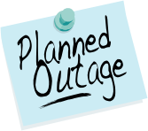
IMPORTANT! – eMARS Year-End System Availability Schedule

eMARS year-end encumbrance roll/lapse process is scheduled to begin upon COB, Friday, July 2, 2010. As a result, eMARS will be unavailable Saturday, July 3, through Monday, July 5.

Users should monitor the eMARS News and Alerts Web site for updates regarding system availability during year-end activity.

Year-End Close and New Year Changes
Frequently Asked Questions
Financial/Accounting FAQs
Q: When will General Fund allotments “collapse”?
A: The General Fund is divided among allotments based upon object types (1-Personnel, 3-Operating, 4-Grants, 5-Debt Service and 6-Capital Outlay). “General fund allotment collapse” means that the general fund balance for all object type allotments may be used to make allowable general fund payments, regardless of the expenditure object. eMARS will still produce processing errors associated with the object type allotments, but beginning July 1, the Office of Statewide Accounting Services (SAS) may override the documents. Please contact your Statewide Accountant for an override.

Q: How are new accounting structures established?
A: New accounting structures (Fund, Function) are established on an SAS-14 form and processed through the Office of the State Budget Director (OSBD).

Q: When will encumbrances roll over to the New Year?
A: Beginning close of business (COB) Friday, July 2, 2010, all 2010 Budget Fiscal Year encumbrances greater than $1,000 (other than Capital Funds) will roll to Fiscal Year 2011 (FY11). In addition, encumbrances less than or equal to $1,000 will lapse, thus closing the respective award. Capital Project encumbrances require no action since their Budget Fiscal Year remains the same throughout the life of the project.

Q: When is the last day to make payments from FY10?
A: The last day to make any type of payment for FY10 is Friday, July 9, 2010. Payments made after July 9 will pay from FY11 funds. The last day to make payments against encumbering awards will be Friday, July 2. The last day to make internal payments via IET; ITI/ITA is Wednesday, June 30.

Q: When is the Hard Close for June (Period 12)?
A: The June Hard Close will be Friday, July 2, 2010.
-Continued-

Q: When are the closing dates for Period 13?
A: The Period 13 Soft Close will be Friday, July 9, 2010. The Hard Close will be Friday, July 16, 2010.

Q: Can FY10 payments post after June 30?
A: FY10 payments may be made via eMARS until COB (7:00 pm) on Friday, July 9. The Budget Fiscal Year (BFY = 2010), Fiscal Year (FY = 2010) and Period (Period = 13) must be entered on the payment document.

Q: Can FY10 receipts post after June 30?
A: FY10 revenue for the General Fund (0100) and Transportation (1100) Funds cannot post to FY10 after June 30. Receipts for all other funds (done on CR documents) must be in the Treasury no later than the COB Friday, July 9.

Q: Where can I find a listing of the last dates that documents may be processed?
A: Refer to the Closing Memo Fiscal Year 2010 document posted on the eMARS Web site @ http://finance.ky.gov/internal/eMARS/ for Last Day to Process Old Year documents.

Procurement FAQs

Note: In each FAQ scenario in this section the amount of the payment must not exceed the balance amount of the contract. In addition, all required EO1s must be approved prior to procurement activity.

Q: How do I liquidate encumbrances that should not roll over to the new Fiscal Year?
A: For all encumbering awards (PON2/PO/CT/DO), Copy Forward and create a zero dollar Payment Request (PRC) document. Mark it Final in the Reference field on both Commodity and Accounting lines. This PRC must be processed by COB Friday, July 2, 2010. A second option is to modify the award to the amount paid/closed on each commodity line.

Q: How do I pay the balance of an award (PON2/PO/CT/DO) in the new Fiscal Year that expired on 6/30/2010 for services/commodities received prior to 6/30/2010?
A: The service dates on the payment document should reflect the actual dates of service, and will occur within the service dates of the award. Payments against expired awards are permitted provided the goods or services were incurred prior to the award expiration date.

Q: How do I pay against a Master Agreement in the New FY that expired on 6/30/2010 for services/commodities received prior to 6/30/2010?
A: If you generally make payments directly referencing a Master Agreement (MA) document, the MA will not be found on URCATS after the expiration date. It will be necessary to create a Delivery Order (DO) and ensure all approvals are applied and the DO is in Final Status prior to the MA expiration if payment is not anticipated until after June 30. Should an agency fail to create a DO prior to the MA expiration date and a payment must be made, create a stand-alone PRC and have a Memo reference to the MA provided the MA does not have catalog line types. If the MA has catalog line type, then a stand-alone PRC should be used for payment with documentation, such as the expired MA, date of service, etc. provided in the Document Description field of the PRC. In both instances, FAP111-09-00-12 should be used as the Cited Authority. These PRC documents will go to the Office of Procurement Services for approval and will only be approved with proper documentation. To avoid this additional step agencies should create a DO for any payment on MAs expiring June 30, 2010 prior to the expiration date.

Q: How do I make a FY10 payment against an encumbering award once the encumbrance rolls on July 2?
A: Once the encumbrances roll to FY11, the payment must reference the award and be paid from FY11. However, you still have an opportunity to JV the funds back to FY10 on a JV2E document until Friday July 16, 2010.

Q: How do I make a payment against an award that lapsed?
A: All encumbrances less than or equal to $1,000 will lapse beginning COB Friday, July 2, 2010. If a payment for goods received or services rendered on non-PON2 awards is required after the lapse, Copy Forward to a PRC document; select Memo as the Reference Type; and use the Small Purchase Authority as the Cited Authority. For PON2 payments on lapsed PON2 awards, Copy Forward to a PRC document; select Memo as the Reference Type; and use the Cited Authority on the referenced PON2 as the Cited Authority on the PRC.

Completing Payment Documents During Period 13
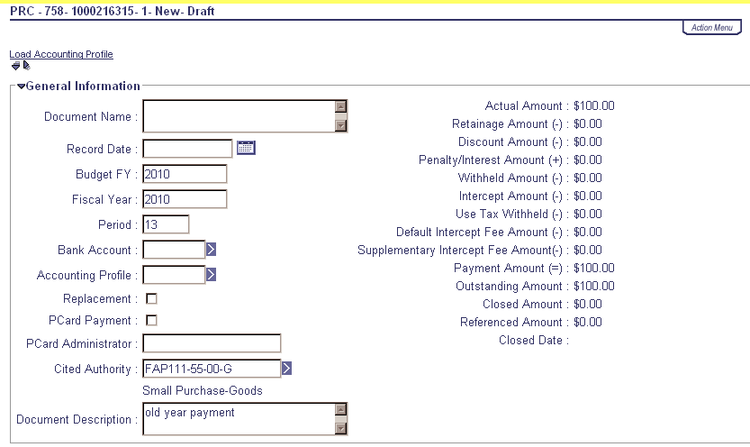
PRC Header
With the Fiscal Year End fast approaching, users who create payment documents are reminded that the fiscal period may need to be entered on their documents. Payments made between July 1 and July 9 have the option to be paid from either 2010 Old Year (OY) funds or 2011 New Year (NY) funds. Users who intend for the payment document to post to Fiscal Year 2010 (FY10), Period 13 (OY) must enter the entire fiscal period on the payment document: Budget FY (2010); Fiscal Year (2010); and Period (13). These fields may be entered on the Header of the payment document or on each Accounting Line. If entered on the Header, the Fiscal Period will apply to all accounting lines on the document.

If the fiscal period is not entered on the payment document, then the current fiscal period (Period 1, 2011) will infer upon final approval.
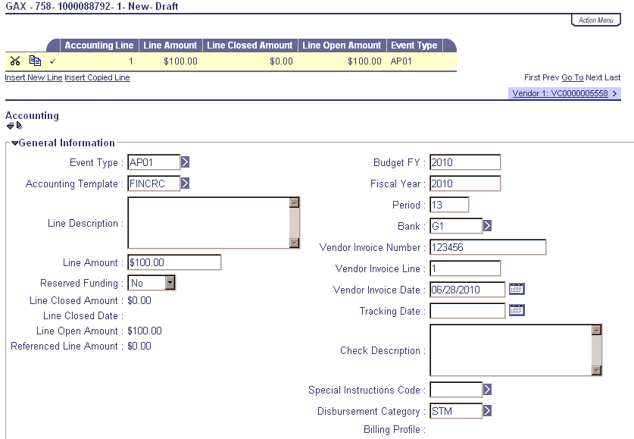
GAX-Accounting Line
Note: Payments created during June (Period 12, 2010) must be submitted and all approvals applied before COB June 30. Otherwise, Period 1, 2011 will be inferred.

For example, a PRC is created and submitted on June 25 with the Budget FY, Fiscal Year and Period left blank; if the final approval is applied before COB June 30, then Period 12, 2010 will be inferred. If the final approval is not applied until July 1, then Period 1, 2011 will be inferred.

In summary, please pay attention to the following points when completing payment documents during Period 13:
Note: These rules do not apply to Capital Funds (BFY=9999).
- The entire Fiscal Period 13 (BFY=2010, FY=2010, Period=13) must be entered on the document. If the BFY is left blank, a staging error is returned.
- Fiscal Period 13 (BFY=2010, FY=2010, Period=13) may be entered on the Header section or on the Accounting line of the document.
  - Fiscal Period entered on the Header will infer on all blank Accounting lines.
  - Fiscal Period entered on an Accounting line will always override Fiscal Period on Header.
  - Fiscal Period 13 (BFY=2010, FY=2010, Period=13) must be entered on the Header section of a PRCI document.
  - Fiscal Period 13 (BFY=2010, FY=2010, Period=13) must be entered on the Header section of a PRC2 document.
- Any Fiscal Period other than Fiscal Period 13 should never be entered on the payment document. If left blank the Fiscal Period will properly infer based on the calendar date at the time the document is submitted to Final phase.
- Fiscal Period 13 payment documents must be submitted to final by COB (7:00 pm), Friday, July 9. Fiscal Period 13 payments against encumbering awards must be submitted to final by COB (7:00 pm), Friday, July 2.


Matching Payments During Period 13

During Fiscal Period 13 (July 1 – July 9) the Fiscal Year and Period on Payment Request Matching (PRM) documents are determined by the Budget Fiscal Year (BFY) on the referenced award at the time the PRM is generated. For example, if the BFY on the referenced award is less than the current BFY (2010<2011), then Fiscal Period 13 (BFY=2010, FY=2010, Period=13) will infer on the PRM. If the BFY is greater than (9999>2010) or equal to (2011=2011) the current BFY, then the current fiscal period (new-year) will infer on the PRM.

Once encumbrances roll the evening of July 2, the BFY on encumbered awards will change from 2010 to 2011. Users should verify their PRM documents to ensure payment from the appropriate fiscal period, which may be done by looking at the Accounting and Posting lines on the PRM document. If the encumbrance is lapsed, the award will close. However, the PRM will continue to generate in “Reject” Status until the user pays via a Copy Forward to a PRC or cancels the eMARS Invoice (IN) document.


Budget Fiscal Year (BFY) 2010 Pending Transactions

Documents submitted with a Phase of Pending affect cash and budget balances. Therefore, expenditure and encumbrance transactions must be cleared by the following dates:
- All Budget Fiscal Year (BFY) 2010 encumbering documents, modifications and cancellations (other than Capital Projects) MUST be submitted to Final phase or rejected back to Draft phase by COB (7:00 pm) Friday, July 2.
- All BFY 2010 pending expenditure documents, modifications and cancellations (other than Capital Projects) MUST be submitted to Final phase or rejected back to Draft phase prior to COB (7:00 pm) Friday, July 9.
Any BFY 2010 documents in Pending phase after the dates specified above will be rejected back to Draft phase by the Office of the Controller.

Note: Departments may utilize the Document Phase Universe-KY in infoAdvantage to assist with locating pending documents or reference the FY 2010 eMARS Pending Transactions.xls file that will be posted under the 2010 Year-End Information link on the eMARS Web site @ http://finance.ky.gov/internal/eMARS/ after June 28.


Friday
2
JULY

Fiscal Year (FY) 2010/2011 Encumbrance Roll/Lapse

The encumbrance roll process to move encumbrances from FY10 to FY11 is scheduled to begin the evening of Friday, July 2, 2010. Only encumbrances greater than $1,000 will roll to the new year (FY11). Encumbrances less than or equal to $1,000 will lapse on July 2, thus closing the awards. This process applies to ALL non-capital fund encumbrances on all award documents including PON2s.

Users should make every effort to clean up or pay old year (FY10) encumbrances prior to COB (7:00 pm) July 2, 2010. Encumbrances may be liquidated by modifying the award document; or creating a zero dollar PRC by using the Copy Forward functionality and selecting Final from the Ref Type drop-down box on all commodity lines. The 2302 Outstanding Encumbrance report within infoAdvantage may be used to aid in clean up efforts.



Payments Against Lapsed Awards

Remember all non-capital encumbrances less than or equal to $1,000 will lapse after COB (7:00 pm) Friday, July 2, 2010. Please adhere to the following when making payments against these awards after July 2:
- Payments against lapsed PON2s
  - Copy Forward to PRC
  - Select “Memo” Reference Type
  - Enter exact Cited Authority from PON2 on PRC
-Continued-
- Payments against all other awards (non-PON2)
  - Copy Forward to PRC
  - Select “Memo” Reference Type
  - Enter FAP 111-55-00 Small Purchase as the Cited Authority

Note: Lapsed awards with an open Invoice (IN) document will generate a Reference Type of “Reject” Status until the user makes payment via a Copy Forward to a PRC per instructions above.


Moving Expenditures Between Fiscal Years

A JV2E document may be used to move expenditures between Budget Fiscal Years.

Example: $100 expenditure was paid from BFY 2011 (new year) and should have been paid
from BFY 2010 (old year).
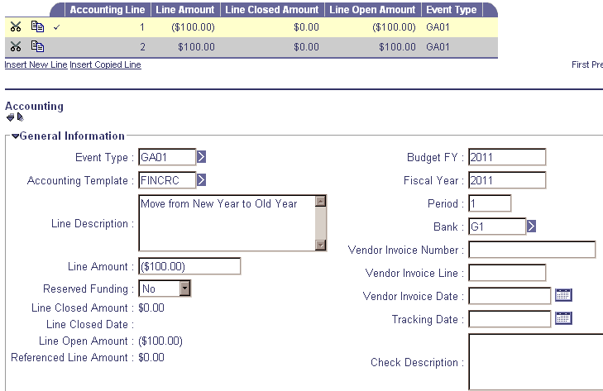

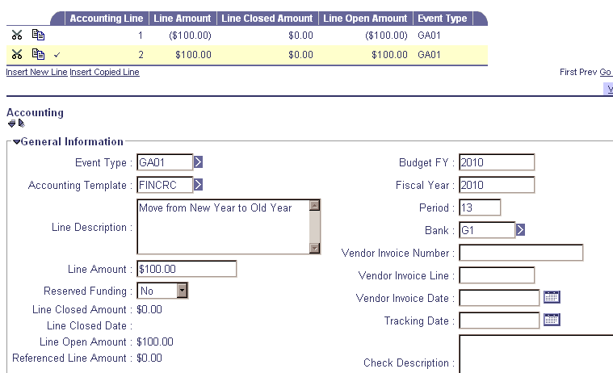
Accounting Line 1 shows a negative ($100.00) and the 2011 Fiscal Period (BFY=2011; FY=2011; Period=1).

Accounting Line 2 shows a positive $100.00 and the 2010 Fiscal Period (BFY=2010; FY=2010; Period=13).

-Continued-
When processing JV2E documents during the fiscal year end, remember the
following:
- JV2Es to move expenditures between BFYs require the Fiscal Period (BFY, FY, and Period) to be entered on the Accounting Line.
- JV2Es with BFY 2010 reference may be processed within the department up to COB (7:00 pm)
July 9.
- JV2Es with BFY 2010 reference processed between July 10 and July 16 will require approval by the Office of the Controller, Statewide Accounting Services.


Closing Schedule Clarification

The dates outlined in the 2010 Closing Schedule for Cost Allocation pertain to internal allocations in those agencies and are not related to multi-agency billings such as COT, Printing, Fleet, etc.


EO1 Process for PSCs, MOAs, and Grants
Updated
Process

Due to the current budget situation, the EO1 committee is only approving expenditures on Personal Service Contracts (PSCs), Memorandum of Agreements (MOAs) and Grants through June 30, 2011. Most PSCs, MOAs and Grants are established for a two-year biennial period. If you were planning to establish your contract for the two-year biennium, you may continue to do so, but EO1s will only be approved for the first fiscal year of expenditures on the contact. Therefore, separate commodity lines need to be established for each fiscal year to correspond to the EO1 amount approved for that year.

The dates entered on all Commodity Lines in the Service From and Service To fields will be for the entire two-year contract period. The commodity line amounts must reflect the contract amounts for year one and year two of the contract. To help distinguish between the two lines, in the commodity line Extended Description state, “this commodity line is for FY11” on line one; and “this commodity line is for FY12” on line two.

The amount of each commodity line must correspond to the EO1 approval for that year. Presently, you will only have EO1 approval for year one. Next year you will need to get EO1 approval for year two. You will have to modify the contract to attach next year’s EO1 approval, but you will not have to change anything on the contract. The mod will be an Administrative Mod and Office of Procurement Services (OPS) will bypass approvals. It will not have to go before the Government Contract Review Committee (GCRC) because nothing on the contract will have changed. The EO1 is an executive process that does not impact the GCRC.
Example: Contract is established for $20,000 and is effective 07-01-10 through 06-30-12. The EO1 approval is for $10,000 through 06-30-11.

- Create two commodity lines for $10,000 each. (Or in another example, if you are going to spend $15,000 during year one and $5,000 during year two, create your commodity lines accordingly. EO1 for year one would have to be $15,000)
- Enter Service From: 07-01-10 and Service To: 06-30-12 on both Commodity lines.
- In the commodity line Extended Description for line one enter “this commodity line is for FY11”.
  - In the commodity line Extended Description for line two enter “this commodity line is for FY12”.
- All accounting information is the same for both lines.
- Prior to 07-01-11, you must obtain EO1 approval for the amount of year two.
- Modify the contract to attach the approved EO1 for year two of the contract. In the Reason for Modification field enter Administrative Modification Only to attach EO1 approval for year two of the contract.


Fixed Assets Update

Property Officers, if you have not already submitted your FY 2010 Physical Inventory Observation reports to the Office of the Controller, please send them to Jennie Wolfe as soon as possible. They are due by the COB Friday, May 28, 2010.

Real Property Closing Packages will be distributed after the year-end process is complete.
Please begin cleaning up your Fixed Assets shells. If possible, submit the shells. If the shells cannot be used, be sure to appropriately enter documents from scratch to record those fixed assets. The target date for having all fixed assets shells for $5,000 and above processed is Sept. 1, 2010.


Report Redevelopment Tips

Agencies should be well on their way redeveloping their Thick Client reports using the new release of WebIntelligence (WebI) available in infoAdvantage. Here are a couple of tips you may find helpful when working on report redevelopment.

Using Tables for Report Header Fields

It is now recommended that tables be used wherever possible in your reports. Tables are easier to manipulate than individual fields. Follow these instructions to use a table for the fields in your report header:
- From Templates, drag a vertical table template into your report header
- Format the table as desired: that is, hide the header row if you do not need it, remove shading, and set the appropriate font and font color. It is recommended that you leave the borders on the cells at this stage, as this makes it easier to align them with other fields in the body of the report.
- Enter labels or formulas in the fields as appropriate.
- Drag the cell borders as needed to align the cells in the new table with any corresponding fields in the body of the report.
- Remove cell borders.

Removing the Timestamp from Date Fields

Often date fields will display timestamps when included in the report. If the timestamp is not desired, formulas may be used to remove it from the date field before display. For example, if you have the following formula displayed as shown:

Formula | Display
=[Date] | 5/13/2010 12:00:00 AM

If you do not want “12:00:00 AM” to be displayed, you should first try to use Format Number to display only the date portion. If that option is not available, change your formula as follows to remove the timestamp from the field.

Formula | Display
=Replace([Date]; " 12:00:00 AM";"") | 5/13/2010

If you were displaying a date entered by the user, your formula would be as follows (where the string Enter Date: exactly matches the text of your prompt).

Formula | Display
=Replace(UserResponse("Enter Date:"); " 12:00:00 AM";" ") | 5/13/2010

If you have tips for report redevelopment that may be of value to other users, please send them to the CRC at Finance.CRCGroup@ky.gov.


Payment Correction

Accidently processing a payment against an award/contract is not a major disaster; it can be corrected. The following will help you place expended monies back onto the contract from which it was originally paid. Before you begin processing the PRC document, you must first make sure that the check processed for the erroneous payment has been deposited using a CR document. Remember to deposit the funds as a refund of expenditure into the exact account from which the expenditure was made. Once the funds have been deposited you may use the following steps to correct the contract document used to initiate the payment.

- Copy Forward from the contract that the payment was issued against to a PRC.

- Enter the Cited Authority (this will be the same Cited Authority as the contract).

- Go to the vendor section and enter in the Invoice Number of CORRECTION and the Vendor Invoice Date.

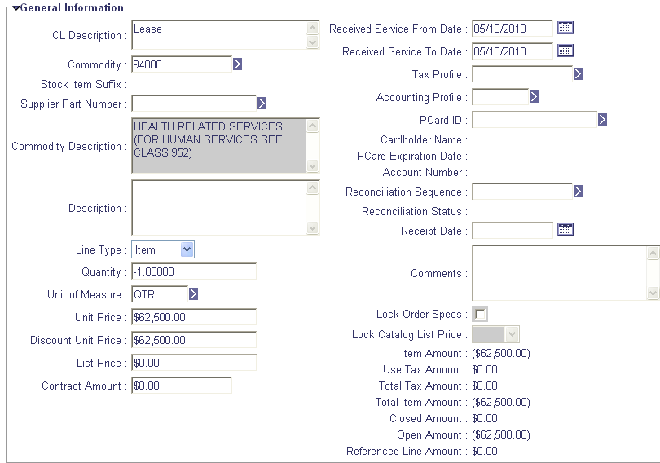
- Navigate to the Commodity section (If the order has multiple lines only leave the commodity line that the payment referenced. Delete all other lines not affected by the erroneous payment).

- Enter in the negative Quantity/ Contract Amount of the erroneous amount paid against that line (This will be the same Quantity/Contract Amount as the payment document that issued the payment/check) (This will place the $ back on the contract line.)

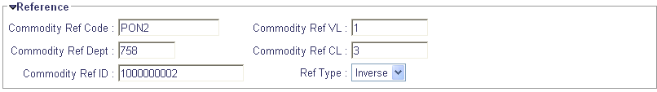
- Open the Reference section and make sure the line is referencing the correct contract Commodity line and mark the Ref Type as Inverse.

- Open the Invoice Information section and record an Invoice Line Number of 1.

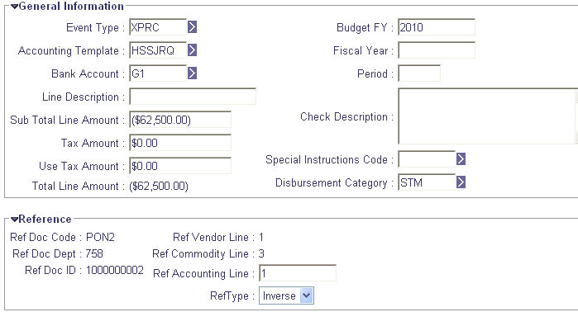
- Click on the Accounting in the Secondary Navigation Panel and validate the document to infer the contract funding.

- Change the Sub Total Line Amount to reflect the same negative amount from the Commodity section.

- Mark the Event Type as XPRC.

- Open the Reference and enter in the appropriate Ref Accounting Line and change the Reference Type to Inverse.

-Continued-

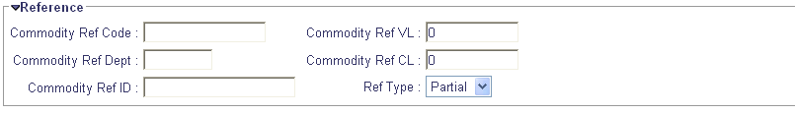
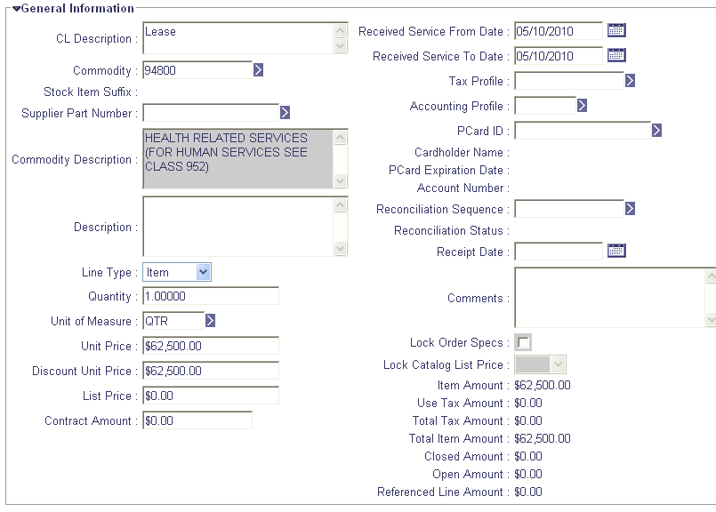
- Return to the Commodity section, copy the existing commodity line and click Insert a Copied Line (this will be the line that will zero out the document).

- Change the dollar amount to a positive number. You may do this by entering a positive quantity if the Line Type was Item, or change the Contract Amount if the Line Type was Service.

- Open the reference section and DELETE the Commodity Ref Code, Dept, ID, VL, CL and the Reference Type that pulled in when the line was copied.

- Open the Invoice information section and enter in the Invoice Line number 2.

- Click on the Accounting link in the Secondary Navigation Panel.

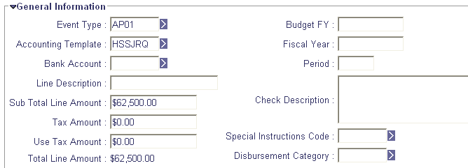
- Click Insert New Line.

- Let the Event Type default to AP01.

- Enter in the Line Amount to reflect the same positive number as in the Commodity section.

- Expand the Fund and Detail Accounting sub-sections and record the required elements.
Note: The funding on this line should match the funding entered for Commodity Line 1.

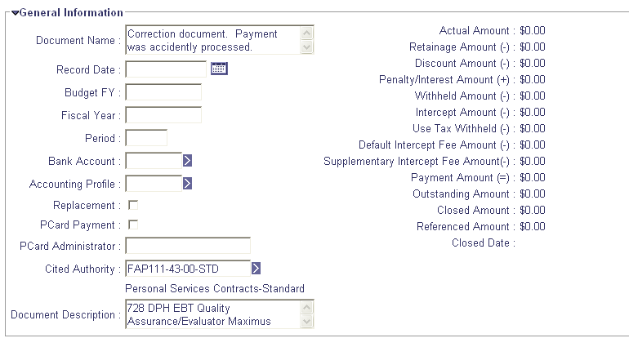
- Go back to the Header of the document. The total amount of the document should be $0.00. This way a check is not issued to the vendor, but the funds are placed back onto the appropriate line.

- In the Document Name field, define the purpose of the document. Explain what happened and why this correction needed to be processed and include relevant document numbers such as the erroneous payment document number and the CR document number.

- Validate and submit the document.

Once the Correction PRC document is processed to Final Status, the previously expended monies will be placed back onto the contract and encumbrance reestablished if applicable.

The steps above may be used against any award type payment. However, award documents requiring matching (i.e. DO, DO2, PO, PO2, CT and CT2) may encounter matching related errors even though the amounts have been placed back onto the contract. Therefore, subsequent payments may need to be paid bypassing the matching process. The Copy Forward option from the award to a PRC should be used in these instances.

The steps above will work in most circumstances. If you need assistance, please contact the Customer Resource Center at Finance.CRCGroup@ky.gov or call 502.564.9641 (toll-free 877.973.HELP) should you have any questions or need assistance.


Reminder -- Use Appropriate Object Codes
Reminder

Object Codes or “E” Codes are used to identify the type of expenditures being obligated against an agency’s budget. These codes are referenced on many reports, both statewide and agency specific. Therefore, in order to get an accurate representation of actual expenditures, it is important to select the appropriate Object Code on award or payment documents. Users should follow these simple guidelines to ensure an accurate Object Code is entered:

- Be sure the Object Code selected is represented within the proper Object Type.
Example: Computer Equipment/Hardware has a specific Object Code within Object Types 3, 6,
and 7.
- Avoid Object Codes with miscellaneous or other as part of the name when possible.
- Use the Expenditure Object Classification report within the Statewide Reports/Chart Of Accounts folder to aid in your selection of proper Object Codes.


New Year Table Initialization (NYTI) Process

On Thursday May 13, 2010, the Office of the Controller ran the New Year Table Initialization (NYTI) process in eMARS. This process copied all active records on all tables keyed by Fiscal Year from the current Fiscal Year (2010) to the new Fiscal Year (2011). Fiscal Officers should review all agency maintained tables (primarily departmental Chart of Accounts (COA) tables) to ensure the active 2011 records are valid.

As part of this process, the Effective To and From dates will be cleared on the 2011 records. Therefore, if your agency uses these dates for a functional purpose, you will need to update the 2011 record on the appropriate table with the dates. Please be aware, if you intend for these records to be effective from July 1, 2010 to June 30, 2011, you do NOT need to update.

If you have any questions concerning this process, please contact the Customer Resource Center at Finance.CRCGroup@ky.gov or via phone at 502.564.9641 (Toll-Free 877.973.4357).


eMARS Training Hiatus

Traditionally, during fiscal year end, the Customer Resource Center (CRC) does not offer eMARS training, allowing agency and CRC staff to devote their time to fiscal year-end activities. During this break in training, CRC staff will also be working to update the training environments to include Fiscal Year 2011 information. We anticipate eMARS training to resume in mid July. However, if your agency has critical eMARS training needs during this time period, contact Donna Hall at 564-9641 ext. 459.

The eMARS End-User Training Schedule posted on the eMARS Web site @ http://finance.ky.gov/internal/eMARS/training_resources.htm will be updated as classes are scheduled. As always, CRC thanks you for your cooperation and understanding.


For more information on eMARS,
please refer to the eMARS Web site @ http://finance.ky.gov/internal/emars/.

