

eMARS Newsletter
October 30, 2008 Issue 23

The eMARS Newsletter is used to disseminate information to agency users on key topics associated with the system.
Inside This Edition

eMARS User Group Meeting
Scheduled – Registration Required 1
infoAdvantage Upgrade to Business
Objects XI 1
EO1 (Executive Order 2008-011)
Update 2
New All State Agency Master
Agreements 2
Vendor Record Clean-Up 2
Catalog Updates 3
PSC Template and PSC Terms and Conditions Revised 3
Travel Authorization (TE) 3
Using the Fixed Asset Transfer (FT) Document 4
CRC Training Announcement 5

Check out the
eMARS Web site @ http://finance.ky.gov/
internal/emars/


eMARS User Group
Meeting Scheduled – Registration Required

Mark your calendars and make plans now to attend the upcoming eMARS User Group Meeting scheduled Wednesday, Nov. 12 from 1:00 to 4:00 PM at the Transportation Office Building Auditorium, 200 Mero Street, in Frankfort, KY. Registration is required to ensure adequate seating is available for this session. If you plan to attend, please contact your Training Team Lead (TTL) to register. A list of TTLs is available on the eMARS Web site @ http://finance.ky.gov/internal/emars/ under the Agency Contacts link. The normal process for registering individuals for eMARS training courses should be followed. Please register for this meeting through your TTL using Class Locator number 0000162915 in Pathlore as shown below.
Contact Donna Hall at 564-9641 ext. 459 if you need assistance registering for the session.

infoAdvantage Upgrade to Business Objects XI


As mentioned in the August 2008, Issue 22 of the eMARS Newsletter, Statewide Accounting Services (SAS) is in the process of upgrading the Business Objects 6.5 software currently used by eMARS infoAdvantage. The August 2008 article stated that the upgrade is targeted for release by year-end 2008, and will take the current Business Objects software from version 6.5 to Business Objects XI (BOXI). Currently, the target date to go live with the BOXI software is scheduled for March 9, 2009.

BOXI upgrade is one of many topics to be presented at the eMARS User Group Meeting scheduled for Nov. 12 at the KYTC Auditorium. Tentatively, the BOXI presentation portion will include the purpose of the project, a definition of the project scope, information on upcoming training and next steps.

If you are unable to attend the user group meeting on Nov. 12, you will have another opportunity to attend an infoAdvantage User Group Meeting on Dec. 2, at the KYTC auditorium. The infoAdvantage User Group meeting will be for all individuals who utilize the infoAdvantage Webi and the infoAdvantage Thick Client software for their reporting needs. Important information will be presented to help you prepare for the upcoming upgrade to BOXI. Individuals will also have an opportunity at this time for a Q & A session with the upgrade team. A notice will be sent out regarding registration for the Dec. 2 infoAdvantage User Group Meeting at a later date.


EO1 (Executive Order 2008-011) Update

If the EO1 Review Committee should determine that additional information is required, the EO1 will be Held and a comment about what is needed will be put in the Document Comments on the EO1. The using agency should review these on Friday afternoons as all actions from the Thursday meeting will be entered by then. The using agency must modify the EO1 adding the wording “Modification” and include the date of the mod with additional information to the top of the Purpose and Justification field, and resubmit the document. Do not add the additional information to Document Comments or as an Attachment as these fields do not print on the report that the Committee reviews. The modified document will appear on the next week’s agenda if all agency approvals have been applied before noon on Wednesday.


New All State Agency Master Agreements

The list provided below identifies new All State Agency Master Agreements issued since July 01, 2008 by the Office of Procurement Services.
Master Agreements that can be used by ALL agencies with an Effective Date of 7/1/2008 or greater
MA Number | Description | Vendor | Effective Date | Expiration Date
MA,758,0800003343,1 | Computer Hardware Security Services | SYSTEMS DESIGN GROUP INC | 7/16/2008 | 7/15/2010
MA,758,0800003344,1 | Computer Hardware Security Services | Clark Schaefer Consulting, LLC | 7/16/2008 | 7/15/2010
MA,758,0800003378,1 | BULK FUEL FOR TANKS - POST #12- FRANKFORT | BOB RILEY DISTRIBUTORS INC | 7/10/2008 | 7/9/2009
MA,758,0800003379,1 | BULK FUEL FOR TANKS - POST #4 ELIZABETHTOWN | KEYSTOPS, LLC | 7/10/2008 | 7/9/2009
MA,758,0800003397,1 | FORKLIFT RENTALS - LOUISVILLE | YALE KENTUCKIANA INC | 7/21/2008 | 7/20/2009
MA,758,0800003398,1 | FORKLIFT RENTALS - LOUISVILLE | LEVEE LIFT INC | 7/21/2008 | 7/20/2009
MA,758,0800003399,1 | Upholstery Fabric | Douglass Industries, Inc. | 7/23/2008 | 7/22/2009
MA,758,0800003407,1 | BULK GAS AND DIESEL -LOUISVILLE | A & M OIL COMPANY INCORPORATED | 7/25/2008 | 7/24/2009
MA,758,0800003414,1 | Security Services Temporary / Emergency | LOGAN SECURITY INC | 8/1/2008 | 7/31/2009
MA,758,0800003515,1 | J & J Carpet and Installation | J AND J IND INC | 9/19/2008 | 9/18/2009
MA,758,0800003521,1 | Footwear- WORK SHOES AND BOOTS | NATIONAL WORKWEAR | 9/17/2008 | 9/17/2009
MA,758,0800003540,1 | Institutional and Healthcare Supplies | Uniforms Manufacturing Inc | 9/29/2008 | 9/29/2009
MA,758,0800003547,1 | State-Wide eScrap Services for end-of life electronic equipment/components | CREATIVE RECYCLING SYSTEMS | 10/1/2008 | 9/30/2010
MA,758,0800003556,1 | Russ Bassett Furniture & Storage | RUSS BASSETT CORP | 10/10/2008 | 10/9/2009
MA,758,0800003570,1 | ONE-WAY PAGERS AND SERVICES | Aquis Communications | 10/17/2008 | 10/17/2010


Vendor Record Clean-Up

The Office of the Controller has recently concluded that many vendor records may be outdated or need to be updated with more current information. To help ensure accuracy of our vendor database, agencies should acquire the most current information when in contact with vendors. When completing VCM or VCC documents verify all information is correct. Special attention should be given to the following: Tax Identification Number, Legal Name, Procurement and Payment Addresses, Phone Number, Fax Number and Contact Information including an accurate e-mail address. Contact the Customer Resource Center (CRC) if you have questions regarding this process or need assistance. The Office of the Controller thanks you for your efforts in assisting us.


Catalog Updates

The catalog-indexing job used to update Master Agreement Catalogs previously ran at the top of every hour. This job schedule created problems for eMARS users who were attempting to approve documents at the time the job was running. To address these problems, a change has been made to the job schedule and the job now runs twice daily- at noon and during the nightly batch cycle. The new job schedule affects the frequency of changes applied to catalog or commodity lines on the MA. If a user is unable to locate a line item after the noon catalog indexing job runs, contact the buyer listed in the Requestor Issuer Buyer section on the Header of the MA for information.

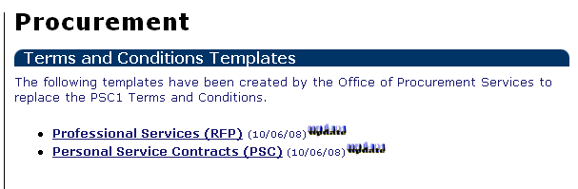
PSC Template and PSC Terms and Conditions Revised

The Professional Services RFP template and the Personal Service Contract (PSC) award template available on the eMARS and the Office of Procurement Services Web sites have been revised. The Legal Services RFP template has been deleted. Agencies who wish to utilize these templates will use the Professional Services RFP template for both standard professional services and legal services. Like the previous templates, these templates may be customized to allow the using agency to include their unique Scope of Work, Requirements, Evaluation Criteria, Proposal Submission Requirements, and Agency Contact Information. The templates also incorporate the PSC1 Terms and Conditions, the Required Affidavit for Offerors and Signature Lines.

To utilize the revised templates, agencies should save a copy of the templates to their local file system and make changes as needed for their RFPs and PON2 contracts. Once the changes are complete, the template must be saved as an XML document and uploaded into the Terms and Conditions of the eMARS RFP and PON2 documents. When attaching the templates to the eMARS document, users should select the Free Form attachment type. The template should be attached to the document through the Action Menu as a Document XML. Users will need to be sure the default Blank Free Form document is deleted from the Attachments page.

The PSC1 clauses available in eMARS have also been revised. The revised terms and conditions are available in eMARS as PSC1 Personal Service Contract - PSC Boilerplate Terms and Conditions Revised Sept. 2008. The previous PSC1 clauses are no longer available.

Agencies should begin utilizing the revised templates and PSC1 Terms and Conditions in eMARS when creating new RFPs and PON2 contracts.


Travel Authorization (TE)
A Travel Authorization (TE) must be submitted for all out-of-state travel. Travel Authorizations may also be submitted for in-state travel to record employee-reimbursable expenses and registration advances to vendors, as well as airfare, hotels and other direct payments to vendors associated with travel of both state and non-state employees. Travel Authorization documents are not required for State Parks and Motor Pool expenses since these transactions are paid through the eMARS IET document. However, utilizing the TE document to capture the cost of these expenses will allow the approver to view the total cost of the trip.

Within eMARS, it is required that the TE document for out-of-state travel be submitted electronically (instead of on paper).
- All out-of-state TE documents must be approved by the Office of the Controller.
- In order for the document to be approved, the TE document must contain ALL expense types. The purpose of this is to show the TOTAL cost of the trip. The total cost includes expenses for registration advance, employee reimbursement, and a Business Travel Account (BTA) used when Airfare is purchased. Note: Including expense lines for Motor Pool and State Parks on the TE will allow the approver to see all expenses associated with the total cost of the trip. Since the payment for these expenses is addressed on the IET eMARS document issued by the billing agency it is not necessary to provide of copy of the TE to Motor Pool or the State Park. -Continued-
- A “non-accounting” event type (XTR01) is used so the funds are not encumbered.
- A TE document may be modified, unless a Travel Payment (TP) document has been submitted for each vendor on the TE document.
- A Travel Authorization Vendor Line should be created for each vendor reimbursement. For example, travel authorizations with both employee-reimbursable expenses and a registration advance must contain at least two vendor lines: one for the employee and the other for the vendor receiving the registration advance. If a BTA Account exists then a third vendor line would need to be added.

A TE may not be used to pay for catering services. These need to be submitted on a PO2 to set up the contract, followed up by a PRC for the payment.

- If your anticipated requirement exceeds your small purchase limit and is less than $20,000, solicit three quotes or post to the Web.
- Using the SR- Solicitation Response or the SRW Solicitation Response Wizard in eMARS tabulate and evaluate responses received to provide documentation justifying the award. Award the PO2 from the EV document (which has been copied forward from the Solicitation, and has had the Solicitation Responses loaded into it.
- The PO2 will route to the Office of Procurement Services based on its referenced Cited Authority. The PO2 needs to contain the following:
- Add Terms and Conditions to the PO2. Note: A blank free form clause is not acceptable. If the agency does not have its own terms and conditions established, choose SMAWRD and incorporate by full text.
- Reference FAP-111-55-00-06 as the Cited Authority.
- At the Header level of the PO2, attach the Determination and Finding (justification) for award, since the reviewer is unable to review the EV document. The Determination and Finding should include the document number, the vendors that responded to the RFB, and their pricing, the reasons for making the award, and the buyer’s name.



Using the Fixed Asset Transfer (FT) Document

Generally, Fixed Asset Transfer (FT) documents are only entered to record reorganizations. However, there are other times when you may want to process an FT document:

- To record the transfer of a fixed asset between departments serving similar functions within the same cabinet (e.g., CHFS);
- To correct the Responsibility Center for a fixed asset where one of the Chart of Accounts elements (e.g., Fund or Function) has become inactive in eMARS.

This article describes the second case. For example, suppose a fixed asset you need to surplus was originally recorded in eMARS using a Responsibility Center Function code of “PAUX”, but that code has since been made inactive or no longer exists in eMARS (perhaps due to a reorganization, or because of the end of a capital project). When you attempt to record the surplus using the Fixed Asset Disposition (FD) document, you receive errors because of the invalid Function code. What can you do?

If the error is overrideable, you may contact Statewide Accounting Services to apply the override. Alternatively, you could process an FT document to clear or correct the invalid Responsibility Center code.

In this example, suppose you decide to clear the Responsibility Center Function code so that your FD document will process. Note that this is something you would only want to do if there will be no further activity for the fixed asset; otherwise you would want to enter a valid Function code instead. Clearing a Responsibility Center field is accomplished by following these steps to process an FT document:
-Continued-
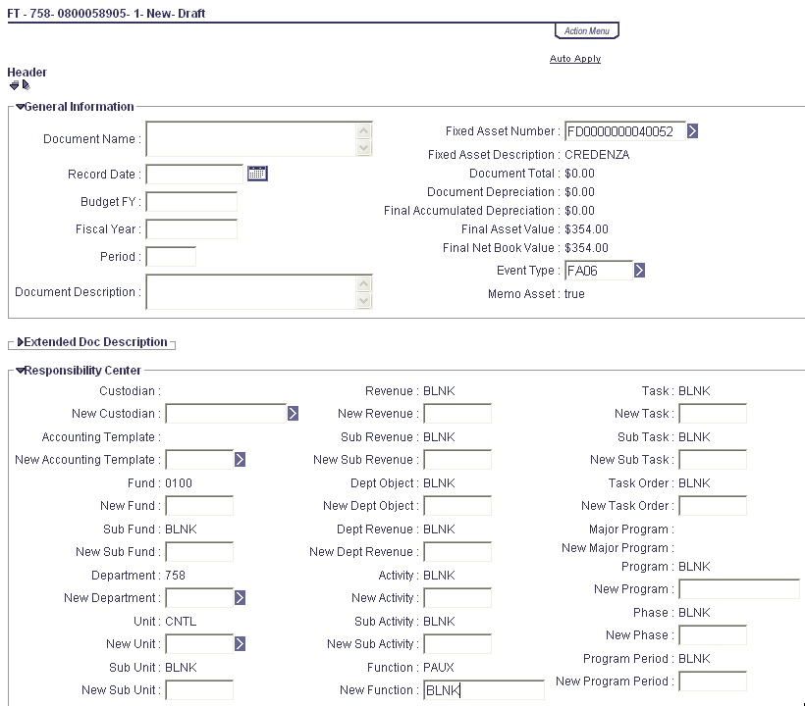
- Create a new FT document and enter the fixed asset tag number in the Fixed Asset Number field. In this example, the Fixed Asset Number is FD0000000040052.

- Click Auto Apply. This brings in the old values for the Responsibility Center fields.

- Enter BLNK in the New Function field for the Responsibility Center, as shown. (BLNK is used when you want to clear a Responsibility Center field; alternatively, you could enter a new valid Function.)

- Click Auto Apply again. This will apply the Function change to all lines on the document.

- Validate, Submit, and Approve your FT document.

Once the FT is processed to Final, the error on your FD document should no longer be issued. Remember, FT documents cannot be processed for transfers between Departments in different Cabinets or for transfers between different types of Funds. As always, these kinds of transfers must be accomplished using the FD/FA combination of documents.

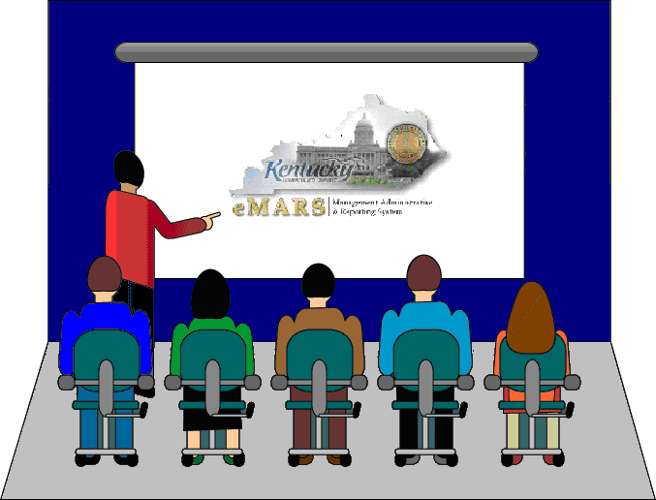
CRC Training Announcement

The eMARS Training Schedule for the next quarter (Oct.-Dec.) has been posted to the eMARS Web site at http://finance.ky.gov/internal/eMARS/training_resources.htm. Please frequent this site for information on upcoming eMARS training opportunities.

Users should note that eMARS 101 Intro to eMARS Independent Study Guide (ISG) and eMARS 110 Chart of Accounts found on the eMARS End-User Training site at http://finance.ky.gov/internal/eMARS/training.htm are prerequisites for all eMARS classes.

If you are interested in registering for any eMARS course, please contact your agency’s Training Team Lead (TTL). A list of TTLs is also available on the eMARS Web site under the Agency Contacts link.


For more information on eMARS,
please refer to the eMARS Web site @ http://finance.ky.gov/internal/emars/.

