

Sept 27, 2007 Issue 16
Inside This Edition
Attention ALL eMARS Users
Document Catalog Searching Changes 1
eMARS Document Assembly with
MS Word 2007 1
infoAdvantage: Purging Reports Prior to Saving/Publishing 1
Business Objects “Thick (Full) Client” Software: Important Information for Purchase and Installation 2
KY-COA: Kentucky Specific Chart of Accounts Universe 4
Vendors, Vendors, Vendors 5
Financial Analysis System² (FAS²)
Training Recording Now Available 6
Fixed Assets: Relocations and
Reorganizations 6
The “I” in FI is for “Increase”! 8
eMARS Training Information 8

Check out the
eMARS Web site @ http://finance.ky.gov/
internal/emars/

The eMARS Newsletter is used to disseminate information to agency users on key topics associated with the system.


Attention ALL eMARS Users_
Document Catalog Searching Changes


Search criteria changes are being implemented on the eMARS Document Catalog screen. These changes are necessary to address performance improvements. Beginning Oct. 1, users will need to use the following criteria guidelines when searching for eMARS documents via the Document Catalog screen:
- an asterisk (*) CANNOT be the first element in any field,
- the Document Code is required, and
- at least one of the following is required in addition to Document Code: Document Department, Document ID, Create User ID or Created On.



eMARS Document Assembly with MS Word 2007

CGI has identified an issue with eMARS Document Assembly when using Microsoft MS Word 2007.

It has been determined that an XML document saved in MS Word 2007 is not compatible with the current eMARS functionality used for document assembly. Using this version of MS Word may cause the assembly process to fail. However, if you are using MS Word 2007 simply save your XML document as a MS Word 2003 file format to avoid potential issues. To do this select Save as from the File menu, then change the Save as type to Document XML Word 2003.

If you need assistance with this process, please contact the Customer Resource Center (CRC) via e-mail at Finance.CRCGroup@ky.gov or by phone at 502.564.9641 (toll-free 877.973.4357.)

infoAdvantage: Purging Reports Prior to Saving/Publishing

Purging data from a report prior to saving to Personal Documents or Corporate Documents is important when developing reports for personal use or for use by others within your cabinet or department.

Purging is an action that deletes or removes the data returned by the query or queries from the report. When using the purge feature the report structure (reports, tables, charts, etc.) and formatting is retained. To retrieve the data in the report simply refresh the query as needed.

So why should you purge a report? Purging the report enables you to minimize the size of the report; thus, minimizing the space used in the repository, which is a centralized location that stores resources needed for reporting, including reports stored in the Inbox, Personal or Corporate Documents areas.
-continued on next page-
To save space on the repository, it is important that historical data is not stored in reports in either Personal or Corporate Documents within infoAdvantage. If historical data is needed for reporting purposes at a later date, reports should be saved as a PDF file to a personal drive on the client’s computer or a shared network folder. Once the report is saved as a PDF file the user should then re-open the report, purge the data and resave it to either their Personal or Corporate Documents location within infoAdvantage.

Instructions for exporting reports are available on the eMARS Web site under the link infoAdvantage Enhanced Document Format link.
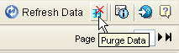

To purge data from a report in infoAdvantage (Webi), click on the Purge Data button, in the top right hand corner, in the Report Panel.

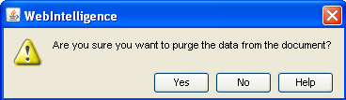
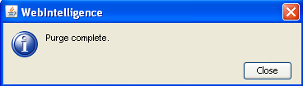
When Purge Data is clicked, you will be asked “Are you sure you want to purge the data from the document?” Click Yes to purge the data from the report. The report may then be saved to Personal or Corporate Documents.
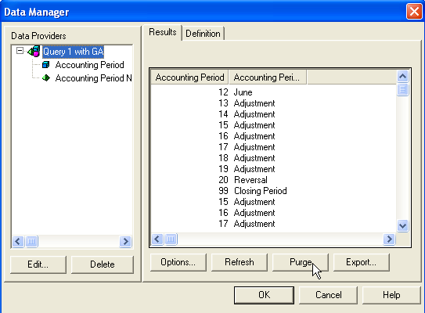

To purge data from a report in Business Objects (Thick Client); first select the query or data provider, and then click on Purge.

Click Yes when Business Objects ask “Are you sure you want to purge the results?”

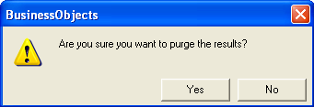

Business Objects “Thick (Full) Client” Software: Important Information for Purchase and Installation

Recently, there has been a growing demand for Business Objects Thick Client Software, which is a Named User License (NUL). The following provides a general overview of the process of purchasing and installing the licensed software.

Purchasing a License
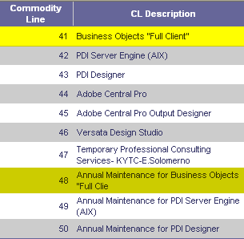
When purchasing the Thick (Full) Client, departments may use the state contract found in the online eMARS Financial system. The contract number is: MA - 758- M-05156962-12

There are two commodity lines related to Business Objects:
- Commodity Line 41 Business Objects “Full Client”
- Commodity Line 48 Annual Maintenance for Business Objects “Full Clie

However, departments may use other vendors instead of the state contract if the purchase price for the software is less than $1,000.

-continued on next page-
If you plan to procure or have procured a Business Objects Thick Client license for use with eMARS, please be advised that you have accepted or will accept the following Terms and Conditions associated with this Named User License:

Named User License (“NUL”). When the Product is licensed on a Named User basis, each individual Named User must be specifically identified as the sole holder of a NUL. A Named User means one specifically identified individual authorized to access the Product. The individual Named User may access only those Product components for which he or she has obtained a NUL. The sharing of the NUL by more than one individual is expressly prohibited and is a material breach of this License Agreement. In addition, NUL(s) may not be transferred from one individual to another unless the original end user no longer requires, and is no longer permitted, access to the Product. NUL(s) are assigned to a single Deployment, and may not be shared among different Deployments. A Deployment means for Business Objects products an installation utilizing a single Repository and/or Security Domain, and for Crystal products a single Crystal Management Server ("CMS") or CMS Cluster. (Excerpt taken from license_agreement.rtf provided with the Business Objects Thick Client Software).

Please Note: There has been an Amendment to the Business Objects contract. A modification to the existing contract (MA - 758- M-05156962-12) will occur to reflect the new price of the Business Objects software. Technically, the current price in the MA has expired and the new pricing actually went into effect July 1, 2007.


Installing the Software

Once the software is purchased and the installation CDs and license are received, the technical support for the department needs to install the software on the user’s computer. Keep in mind that this is a Named User License, so the software must be installed only on a specific user’s computer and licensed to that user. Installation on a shared machine and sharing of one license with multiple users is illegal as stated in the portion of the Terms and Conditions in this article.

Oracle 9i is needed prior to the installation of Business Objects Thick Client and it must be installed first. Once Oracle 9i is installed, then Business Objects Thick Client (version 6.5) may be installed. Until further notice, the software version is 6.5. Service Pack 2 should also be installed at the same time. Without Service Pack 2, the software does not function properly.

Several other files are also needed for the installation. The department’s technical support may contact the Customer Resource Center (CRC) to obtain these additional files and instructions for where the files need to be loaded on the user’s computer: The following provides the names of the additional files needed and a brief description of each.
- bomain_KY_Prod_2.key Points the software to the repository and universes.
- sqlnet.ora Contains sequel needed for connection to the universes.
- TNSNames.ora Connects Business Objects to the universes.

After the software is installed, the user must have their Security Lead contact the CRC to request that access be granted to log into the software. This is done by setting up a password for the Thick Client software. A list of department Security Leads may be found on the eMARS Web site at http://finance.ky.gov/internal/eMARS/Agency+Contacts.htm (under the Agency Contact Listings link.)

Please Note: At this point in time, neither the CRC nor Statewide Accounting Services (SAS) will give users access to Thick Client unless the request is sent via email from the department’s Security Lead to the CRC. Access will only be granted once the software has been set up on the user’s computer. Verification of an individual license for the named user may be requested prior to authorizing access to the universes via Thick Client. As well, so that the CRC and SAS may stay in compliance with Business Objects licensing agreements, users may not attend Thick Client training until the purchased software is installed and access is granted for Thick Client reporting. Each enrollment in the Thick Client training class is followed up with verification of an individual Named User License.


KY-COA: Kentucky Specific Chart of Accounts Universe

To assist with Chart of Account (COA) type reports a new infoAdvantage Universe is now available. The new KY-COA Universe contains the two data classes shown below. By using this universe, users may now create a COA report at the Function or Sub-Function level or a COA report to the Fund level. However, a Fund-Function combination report is not attainable since there is no data relationship between Fund and Function data elements at this time. The following screenshots are of the data classes contained within the KY-COA Universe:
KY-Function Class  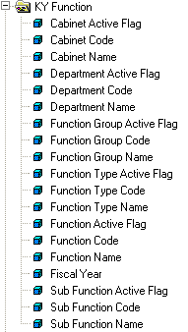  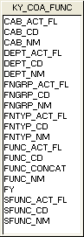  Class is made up of KY_COA_FUNC table. | KY-Fund Class  Class is made up of KY_COA_FUND table.  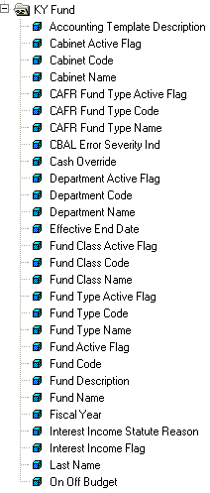  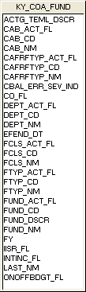
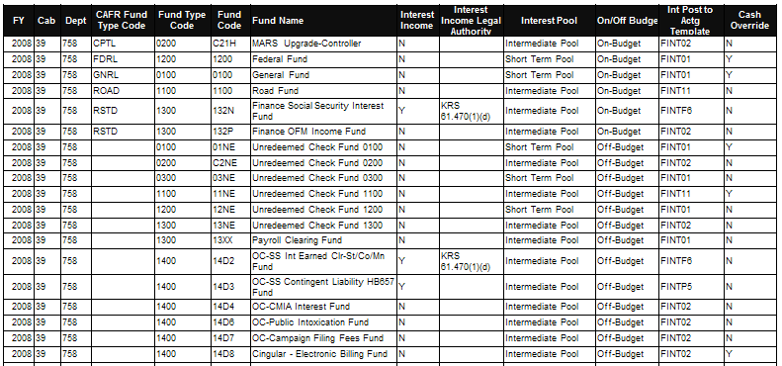
An example of a Fund report is as follows:

An example of a Function report is as follows:
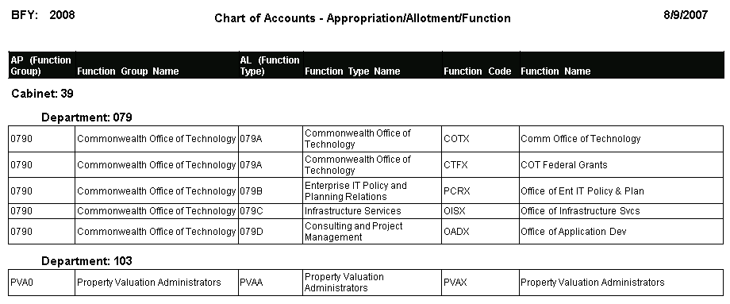

Vendors, Vendors, Vendors

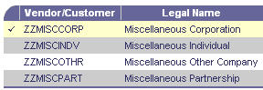
Did you know that for one-time or infrequent payments there are miscellaneous vendors that may be used? The following four miscellaneous vendor codes shown below are setup in eMARS for this purpose.

Using these vendors requires more information to be entered on the payment request (i.e. name, address, and taxpayer information if the object is 1099 reportable). However, by utilizing these vendor codes for those one-time or infrequent payments, you will save time and effort by not having to create a new vendor customer record within eMARS.

When creating VCC documents, there are certain fields that the Controller's Office requires completion with specific values. This vendor checklist below shows the fields that are required and the specified values. Beginning Oct. 15, any VCC or VCM document that does not have these values correct will be rejected by Statewide Accounting Services (SAS.) Rejecting VCC or VCM documents could potentially cause delays in other documents needing to be processed that reference the vendor customer code. Please spend a few minutes verifying the information in these fields before submitting the VCC/VCM to ensure all values are correct. Doing so will save time and ensure accuracy of our vendor information.

The following list identifies the fields and the specified value for each as required by SAS when submitting VCC or VCM documents.

- Vendor Customer Tab
General Information Section  - Vendor Customer – Begins with VC or VS  - Auto Generate - Checked  - Location Name – Needs to be Address Line 1 from  the address  - Organization Type – Must be entered  Account Indicators Section  - None of these should be checked without justification  in comments  Organization Section  - Classification – Must be entered  - Taxpayer ID Number – Must be entered and valid  - Taxpayer ID Number Type – Must be entered and valid | Disbursement Options Section  - Category – STM  - Default Priority – 99  - Default Format – REG  - Scheduled Payment Day - blank  - Single Payment Indicator- Checked  - Name on Check – Both  Prenote/EFT Section  If EFT payments are requested:  - Generate EFT Payment – Checked  - ABA Number – Entered and valid  - Account Type – Checking or Savings  - Account Number – Entered  - EFT Format – CCD  - EFT Status – Eligible for EFT
- Address Tab
- There must be at least two addresses (one payment and one procurement)
- For Address, Address ID should be AD001 and Phone Number is required.
- For Contact, Contact ID should be PC001, Contact, and Phone are required
- Default Record – Checked for Payment and Procurement address
- 1099 Reporting Information Tab
Taxpayer Information Section  - Vendor Customer, Taxpayer ID Number, TIN Type Must be entered  - Name, Address, City, State, Zip Code – Must be entered  - 1099 Reportable – Checked | - 1042-S Reportable Information  Section - All fields left blank
- Business Type Tab
- Business Type ID – Must have one business type entered
- Certification Tab
- Vendor Active Status – Active
- Vendor Certification Status - Complete





Financial Analysis System² (FAS²) Training Recording Now Available

A prerecorded Elluminate training segment is now available on the eMARS Web site @ http://finance.ky.gov/internal/eMARS/training.htm for the Financial Analysis System² (FAS²). Elluminate recordings offer navigation buttons that allow the user to stop and start the training as needed and listen at their leisure.


Fixed Assets: Relocations and Reorganizations

Is your department relocating? Is your cabinet reorganizing? As you know, these common events in state government wreak havoc on fixed assets/inventory reports. When hundreds or thousands of items shift responsibility overnight, what’s a Property Officer to do?

If only the physical location or custodian of a fixed asset changes, Fixed Asset Modification (FM) documents are the way to go. For re-organizations where fiscal responsibility changes, however, other questions arise.

When can we use Fixed Assets (FT) documents?
FY08 Fund Types
- Governmental: 0100, 0200, 0300, 1100, 1200, 1300, 1400, 6300, 6310, 6350
- Proprietary or Other: 2100, 2200, 2400, 2500, 2800, 2900, 3100, 3200, 3500, 3600, 3700, 3800, 5000 series, 6200, 6210, 7200, 7250

FY08 Departments by Governmental Function
- Commerce: 235, 635, 637, 638, 639, 660, 665, 670, 850, 852, 855, 860
- Education & Humanities: 183, 340, 407, 410, 415, 529, 530, 531, 540, 545, 550, 552, 555
- General Government: 030, 035, 040, 045, 066, 070, 074, 075, 076, 079, 080, 082, 084, 085, 089, 094, 095, 097, 098, 099, 100, 103, 110, 112, 120, 125, 130, 150, 155, 165, 170, 172, 173, 174, 176, 177, 180, 182, 185, 190, 200, 205, 210, 215, 225, 230, 240, 245, 250, 255, 260, 261, 262, 263, 264, 268, 270, 275, 280, 284, 290, 295, 310, 315, 320, 345, 354, 370, 391, 395, 400, 430, 435, 440, 445, 450, 455, 460, 465, 470, 560, 627, 750, 756, 758, 759, 765, 785, 790, 793, 794, 931, 933, 935, 937, 939, 941, 942, 943, 945, 947, 949, 951
- Human Resources: 721, 722, 723, 724, 725, 726, 728, 729, 730, 731, 736, 746, 748, 767
- Justice: 500, 502, 515, 520, 523, 525, 527
- Legislative & Judicial: 005, 010, 020, 025
- Natural Resources & Environmental Protection: 350, 375, 569, 590, 595
- Public Protection & Regulation: 380, 423, 424, 695, 920, 930
- Transportation: 605, 606, 607, 609, 610, 612, 615, 616, 617, 621, 625, 628, 630
One key reason for tracking fixed assets is to meet Comprehensive Annual Financial Report (CAFR) guidelines. In the past, re-organizations within a cabinet were relatively straightforward: Fixed Asset Transfer (FT) documents were processed to change the Responsibility Center for each fixed asset affected. The Commonwealth’s current organization, however, is not fully aligned to match the CAFR Governmental Function structure, so Property Officers must have a higher awareness of CAFR guidelines.

Specifically, FT documents are only used when:

- The re-organization is between governmental funds or within the same proprietary fund, and
- The re-organization is between departments that serve the same governmental function (according to CAFR guidelines, unless otherwise arranged with the Controller’s Office).

If a re-organization does not meet both of these requirements, fixed assets must be disposed for the old department on Fixed Assets Disposition (FD) documents (using Disposition Method = ‘A’ = Transfer to Another State Agency) and entered again for the new department on Fixed Assets Acquisition (FA) documents (using Acquisition Method = ‘T’ = Transfer from State Agency).
-continued on next page-
What if the fixed assets are not moving as part of a relocation?

Sometimes when a department relocates, fixed assets are left for the use of those moving in. In this case, one important responsibility of our Property Officers is to communicate with the incoming Property Officer regarding transition of responsibility for those fixed assets.

In eMARS, the physical location of a fixed asset is identified by the Sub Location code, which is defined within Department. Therefore, the incoming Property Officer may have to request new Sub Location codes for the department moving in before the transfer of the fixed assets may be recorded in eMARS.

Must documents be entered manually?

There are spreadsheets on the eMARS Web page @ http://finance.ky.gov/internal/eMARS/fixed_assets.htm for the FA, FD, FM and FT documents to help departments automate the reorganization process somewhat. Fixed asset data may be gathered by Unit or by Sub Location using infoAdvantage reports, updated to reflect the new information (e.g., Custodian, Fund, Department, Unit, Sub Location), organized into the required format in the spreadsheet, and uploaded to eMARS.

What are the steps for a re-organization or relocation?

Below is a suggested checklist to help you structure your department’s relocation or re-organization.

Done? | Suggested Step
✓ | - If some of the affected fixed assets are transferred under the responsibility of another Property Officer, make contact with that person. (The Agency Contacts spreadsheet on the eMARS Web site provides a list of Property Officers.)
✓ | - Determine whether you will be able to use FT documents or if you must process FD/FA documents.
✓ | - Unless you are entering the documents manually, obtain the necessary document spreadsheets from the eMARS Web page and become familiar with them (contacting SAS for assistance where needed). Hide any “Optional” columns you do not need.
✓ | - Pull fixed asset data for the locations affected from infoAdvantage into a spreadsheet, using the statewide daily reports or a custom report.
✓ | - Determine whether new Sub Location codes are needed for any of the affected departments. (Remember, because Sub Location is defined within Department, the same physical location has different Sub Location codes for different Departments.)
✓ | - Create spreadsheet(s) with the required information for each fixed asset, including document code (FT or FA/FD), New Custodian, New Fund, New Department, New Unit, New Sub-Location; and any required dates (e.g., Disposition Date, Acquisition Date). You may desire to do this on your own spreadsheet and then copy the data to the eMARS document spreadsheets after it is finalized.
✓ | - Provide data for any fixed assets you are leaving behind to the incoming Property Officer. Ideally, you should not process the FD documents for these items until the incoming Property Officer has recorded the fixed assets in the incoming department.
✓ | - Enter the required FT, FD and/or FA documents, either manually or by uploading the spreadsheets through SAS. (Please note that each spreadsheet upload requires three days to a week for testing.)
✓ | - Approve the documents. If documents are loaded through a spreadsheet, submission of the spreadsheet is considered Property Officer approval, so documents are loaded and processed with approvals bypassed.
✓ | - Pull reports to verify results. Use the statewide daily reports or custom infoAdvantage reports to ensure that your inventory is complete with all fixed assets recorded with the appropriate Custodian, Fund, Department, Unit, and Sub Location.

The “I” in FI is for “Increase”!

When processing Fixed Assets Increase/Decrease (FI) documents to change the funding information for a fixed asset, remember that the “I” stands for “Increase”. Enter the amount of the increase or decrease – not the asset value. For a decrease, the amount must be entered with a minus sign.

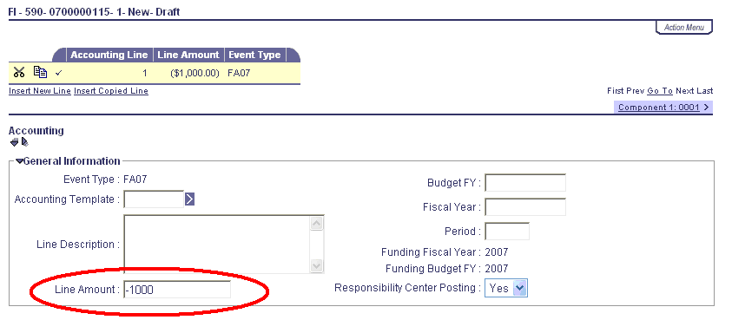
For example, suppose you had a fixed asset entered in eMARS for $7,580 when its value was actually $6,580. To decrease the value of a fixed asset by $1,000, enter “-1000” on the Accounting Line as shown.

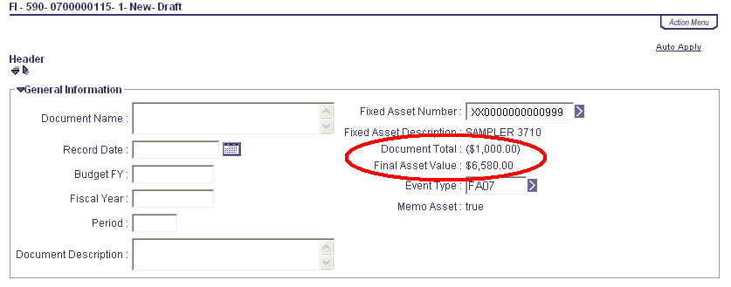

Before processing the FI, validate it and review the header. If the Final Asset Value is not correct, review the FI Accounting Lines and make sure the Line Amount fields show increases or decreases correctly.


eMARS Training Information

The Customer Resource Center is soon relocating to our new location at 1049 US 127 South. We are anticipating our move to occur around mid October. While we have appreciated the training accommodations provided by the Kentucky Transportation Cabinet (KYTC), we are excited about having our own training rooms at the new facility.

During the first part of October, all training are held at the KYTC building on Mero Street. Once we are relocated, we will begin offering classes at our new site. Please, continue to reference the eMARS End-User Training Schedule to identify the training site location for classes offered. The training schedule for the third quarter is now available on the eMARS Web site @ http://finance.ky.gov/internal/eMARS/. Modifications are made to the training schedule to include the eMARS Class Code and Locator Numbers required for the Pathlore registration application. This information is helpful to the Training Team Leads (TTLs) when registering users for a class.

Also, we want to welcome Donna Hall to our CRC team. Donna joined our staff on August 1 as the new CRC Training Coordinator. She is performing responsibilities formerly handled by Kathy Hutcherson who retired on July 30. If you have questions specific to eMARS training, please feel free to contact Donna at 564-9641 ext 118. or via e-mail at DonnaS.Hall@ky.gov.

