

eMARS Newsletter
May 18, 2011 Issue 33

The eMARS Newsletter disseminates information to agency users on key topics associated with the system.
Inside This Edition
IMPORTANT! – eMARS Year-End System Availability Schedule 1
Year-End Close and New Year Changes Frequently Asked Questions 1
Completing Payment Documents During Period 13 3
Matching Payments During Period 13 4
Budget Fiscal Year (BFY) 2011 Pending Transactions 4
Fiscal Year (FY) 2011/2012 Encumbrance Roll/Lapse 4
Payments Against Lapsed Awards 5
Moving Expenditures Between Fiscal Years 5
Fixed Assets Update 6
New Year Table Initialization (NYTI) Process 7
eMARS Training Hiatus 7
eMARS Schedule on Furlough Weekends 7


Check out the eMARS Web site @ http://finance.ky.gov/
internal/emars/

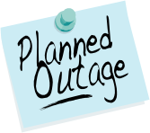
IMPORTANT! – eMARS Year-End System Availability Schedule

eMARS year-end encumbrance roll/lapse process is scheduled to begin at close of business on Friday, July 1, 2011. As a result, eMARS will be unavailable Saturday, July 2, through Monday, July 4. NOTE: All references to close of business, or COB, refer to 7:00 p.m. EDT on the date cited.

Users should monitor the eMARS News and Alerts Web site for updates regarding system availability during year-end activity.

Year-End Close and New Year Changes
Frequently Asked Questions
Financial/Accounting FAQs
Q: When will General Fund allotments “collapse”?
A: The General Fund is divided among allotments based upon object types (1-Personnel, 3-Operating, 4-Grants, 5-Debt Service and 6-Capital Outlay). “General fund allotment collapse” means that the general fund balance for all object type allotments may be used to make allowable general fund payments, regardless of the expenditure object. eMARS will still produce processing errors associated with the object type allotments, but beginning July 1, the Office of Statewide Accounting Services (SAS) may override the documents. Please contact your Statewide Accountant for an override.

Q: How are new accounting structures established?
A: New accounting structures (Fund, Function) are established on an SAS-14 form and processed through the Office of the State Budget Director (OSBD).

Q: When will encumbrances roll over to the New Year?
A: Beginning at COB (7:00 p.m.) on Friday, July 1, 2011, all 2011 Budget Fiscal Year encumbrances greater than $1,000, excluding Capital Funds, will roll over to Fiscal Year 2012. In addition, encumbrances less than or equal to $1,000 will lapse, thus closing the respective award. Capital Project encumbrances require no action since their Budget Fiscal Year remains the same throughout the life of the project.

Q: When is the last day to make payments from FY11?
A: The last day to make any type of payment for FY11 is Friday, July 8, 2011. Payments made after July 8 will pay from FY12 funds. The last day to make payments against FY11 encumbering awards will be Friday, July 1. The last day to make internal payments via IET; ITI/ITA is Thursday, June 30.

Q: When is the Hard Close for June (Period 12)?
A: The June Hard Close will be Tuesday, July 5, 2011.
-Continued-

Q: When are the closing dates for Period 13?
A: The Period 13 Soft Close will be Friday, July 8, 2011. The Hard Close will be 12:00 p.m. EDT Friday, July 15, 2011.

Q: Can FY11 payments post after June 30?
A: FY11 payments (non-encumbrance) may be made via eMARS until COB (7:00 p.m.) on Friday, July 8. The Budget Fiscal Year (BFY = 2011), Fiscal Year (FY = 2011) and Period (Period = 13) must be entered on the payment document.

Q: Can FY11 receipts post after June 30?
A: FY11 revenue for the General Fund (0100) and Transportation (1100) Funds cannot post to FY11 after June 30. Receipts for all other funds (done on CR documents) must be in the Treasury no later than COB (7:00 p.m.) on Friday, July 8.

Q: Where can I find a listing of the last dates that documents may be processed?
A: Refer to the Closing Memo - Fiscal Year 2011 document posted on the eMARS Web site at http://finance.ky.gov/internal/eMARS/ for Last Day to Process Old Year documents.

Procurement FAQs

Note: In each FAQ scenario in this section the amount of the payment must not exceed the balance amount of the contract. In addition, all required EO1s must be approved prior to procurement activity.

Q: How do I liquidate encumbrances that should not roll over to the new Fiscal Year?
A: For all encumbering awards (PON2/PO/CT/DO), Copy Forward and create a zero dollar Payment Request (PRC) document. Mark it Final in the Reference field on both Commodity and Accounting lines. This PRC must be processed by COB on Friday, July 1, 2011. A second option is to modify the award to the amount paid/closed on each commodity line.

Q: How do I pay the balance of an award (PON2/PO/CT/DO) in the new Fiscal Year that expired on June 30, 2011 for services/commodities received prior to June 30, 2011?
A: The service dates on the payment document should reflect the actual dates of service, and will occur within the service dates of the award. Payments against expired awards are permitted provided the goods or services were incurred prior to the award expiration date.

Q: How do I pay against a Master Agreement in the New FY that expired on June 30, 2011 for services/commodities received prior to June 30, 2011?
A: If you generally make payments directly referencing a Master Agreement (MA) document, the MA will not be found on URCATS after the expiration date. It will be necessary to create a Delivery Order (DO) and ensure all approvals are applied and the DO is in Final Status prior to the MA expiration if payment is not anticipated until after June 30. Should an agency fail to create a DO prior to the MA expiration date and a payment must be made, create a stand-alone PRC and have a Memo reference to the MA provided the MA does not have catalog line types. If the MA has catalog line type, then a stand-alone PRC should be used for payment with documentation, such as the expired MA, date of service, etc. provided in the Document Description field of the PRC. In both instances, FAP111-09-00-12 should be used as the Cited Authority. These PRC documents will go to the Office of Procurement Services for approval and will only be approved with proper documentation. To avoid this additional step, agencies should create a DO for any payment on MAs expiring June 30, 2011 prior to the expiration date.

Q: How do I make a FY11 payment against an encumbering award once the encumbrance rolls on July 1?
A: Once the encumbrances roll to FY12, the payment must reference the award and be paid from FY12. However, you still have an opportunity to JV the funds back to FY11 on a JV2E document until 12:00 pm EDT Friday July 15, 2011.

Q: How do I make a payment against an award that lapsed?
A: All encumbrances less than or equal to $1,000 will lapse beginning COB (7:00 p.m.), Friday, July 1, 2011. If a payment for goods received or services rendered on non-PON2 awards is required after the lapse, Copy Forward to a PRC document; select Memo as the Reference Type; and use the Small Purchase Authority as the Cited Authority. For PON2 payments on lapsed PON2 awards, Copy Forward to a PRC document; select Memo as the Reference Type; and use the Cited Authority on the referenced PON2 as the Cited Authority on the PRC.

Completing Payment Documents During Period 13
PRC-Header
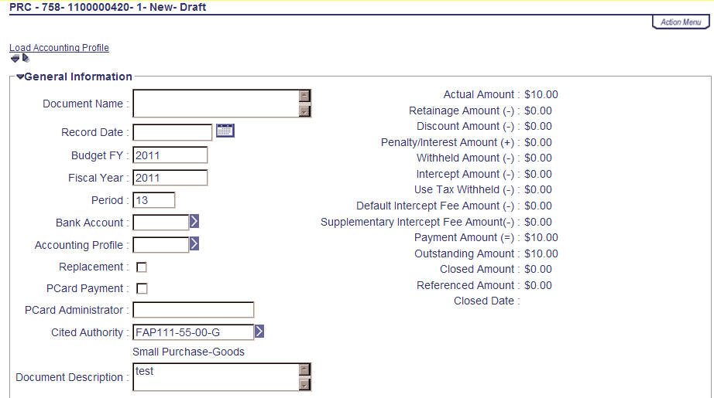
With the Fiscal Year End fast approaching, users who create payment documents are reminded that the fiscal period may need to be entered on their documents. Payments made between July 1 and July 8 have the option to be paid from either 2011 Old Year funds or 2012 New Year funds. Users who intend for the payment document to post to Fiscal Year 2011, Period 13 must enter the entire fiscal period on the payment document: Budget FY (2011); Fiscal Year (2011); and Period (13). These fields may be entered on the Header of the payment document or on each Accounting Line. If entered on the Header, the Fiscal Period will apply to all accounting lines on the document.

If the fiscal period is not entered on the payment document, then the current fiscal period (Period 1, 2012) will infer upon final approval.
GAX-Accounting Line
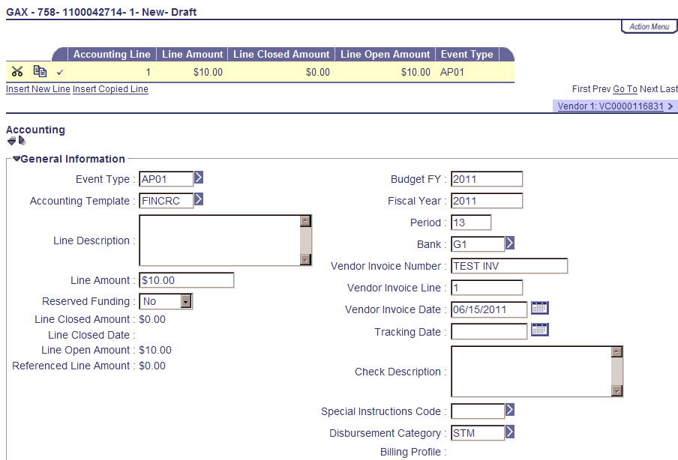
Note: Payments created during June (Period 12, 2011) must be submitted and all approvals applied before COB (7:00 p.m.) on June 30. Otherwise, Period 1, 2012 will be inferred.

For example, a PRC is created and submitted on June 25 with the Budget FY, Fiscal Year and Period left blank; if the final approval is applied before COB June 30, then Period 12, 2011 will be inferred. If the final approval is not applied until July 1, then Period 1, 2012 will be inferred.

In summary, please pay attention to the following points when completing payment documents during Period 13:
Note: These rules do not apply to Capital Funds (BFY=9999).
- The entire Fiscal Period 13 (BFY=2011, FY=2011, Period=13) must be entered on the document. If the BFY is left blank, a staging error is returned.
- Fiscal Period 13 (BFY=2011, FY=2011, Period=13) may be entered on the Header section or on the Accounting line of the document.
  - Fiscal Period entered on the Header will infer on all blank Accounting lines.
  - Fiscal Period entered on an Accounting line will always override Fiscal Period on Header.
  - Fiscal Period 13 (BFY=2011, FY=2011, Period=13) must be entered on the Header section of a PRCI document.
  - Fiscal Period 13 (BFY=2011, FY=2011, Period=13) must be entered on the Header section of a PRC2 document.
- Any Fiscal Period other than Fiscal Period 13 should never be entered on the payment document. If left blank the Fiscal Period will properly infer based on the calendar date at the time the document is submitted to Final phase.
- Fiscal Period 13 payment documents must be submitted to final by COB (7:00 p.m.), Friday, July 8. Fiscal Period 13 payments against encumbering awards must be submitted to final by COB (7:00 p.m.), Friday, July 1.


Matching Payments During Period 13

During Fiscal Period 13 (July 1 – July 8) the Fiscal Year and Period on Payment Request Matching (PRM) documents are determined by the Budget Fiscal Year (BFY) on the referenced award at the time the PRM is generated. For example, if the BFY on the referenced award is less than the current BFY (2011<2012), then Fiscal Period 13 (BFY=2011, FY=2011, Period=13) will infer on the PRM. If the BFY is greater than (9999>2012) or equal to (2012=2012) the current BFY, then the current fiscal period will infer on the PRM.

Once encumbrances roll the evening of July 1, the BFY on encumbered awards will change from 2011 to 2012. Users should verify their PRM documents to ensure payment from the appropriate fiscal period, which may be done by looking at the Accounting and Posting lines on the PRM document. If the encumbrance is lapsed, the award will close. However, the PRM will continue to generate in “Reject” Status until the user pays via a Copy Forward to a PRC or cancels the eMARS Invoice (IN) document.



Budget Fiscal Year (BFY) 2011 Pending Transactions

Documents submitted with a Phase of Pending affect cash and budget balances. Therefore, expenditure and encumbrance transactions must be cleared by the following dates:

- All Budget Fiscal Year (BFY) 2011 encumbering documents, modifications and cancellations (other than Capital Projects) MUST be submitted to Final phase or rejected back to Draft phase by COB (7:00 p.m.), Friday, July 1.
- All BFY 2011 pending expenditure documents, modifications and cancellations (other than Capital Projects) MUST be submitted to Final phase or rejected back to Draft phase prior to COB (7:00 p.m.), Friday, July 8.
Any BFY 2011 documents in Pending phase after the dates specified above will be rejected back to Draft phase by the Office of the Controller.

Note: Departments may utilize the Document Phase Universe-KY in infoAdvantage to assist with locating pending documents or reference the FY 2011 eMARS Pending Transactions.xls file that will be posted under the Year-End Information on the eMARS Web site @ http://finance.ky.gov/internal/eMARS/ after June 28.



Fiscal Year (FY) 2011/2012 Encumbrance Roll/Lapse

The encumbrance roll process to move encumbrances from FY11 to FY12 is scheduled to begin the evening of Friday, July 1, 2011. Only encumbrances greater than $1,000 will roll to closing the awards. This process applies to ALL non-capital fund encumbrances on all award documents including PON2s.

Users should make every effort to clean up or pay old year (FY11) encumbrances prior to COB (7:00 p.m.), July 1, 2011. Encumbrances may be liquidated by modifying the award document; or creating a zero dollar PRC by using the Copy Forward functionality and selecting Final from the Ref Type drop-down box on all commodity and accounting lines. The 2302 Outstanding Encumbrance report within infoAdvantage may be used to aid in clean up efforts.


Payments Against Lapsed Awards

Remember all non-capital encumbrances less than or equal to $1,000 will lapse after COB (7:00 p.m.), Friday, July 1, 2011. Please adhere to the following when making payments against these awards after July 1:

- Payments against lapsed PON2s
  - Copy Forward to PRC
  - Select “Memo” Reference Type
  - Enter exact Cited Authority from PON2 on PRC
- Payments against all other awards (non-PON2)
  - Copy Forward to PRC
  - Select “Memo” Reference Type
  - Enter FAP 111-55-00 Small Purchase as the Cited Authority

Note: Lapsed awards with an open Invoice (IN) document will generate a PRM in “Reject” Status until the user makes payment via a Copy Forward to a PRC per instructions above.


Moving Expenditures Between Fiscal Years

A JV2E document may be used to move expenditures between Budget Fiscal Years.

Example: $100 expenditure was paid from BFY 2012 (new year) and should have been paid
from BFY 2011 (old year).

Accounting Line 1 shows a negative ($100.00) and the 2012 Fiscal Period (BFY=2012; FY=2012; Period=1).
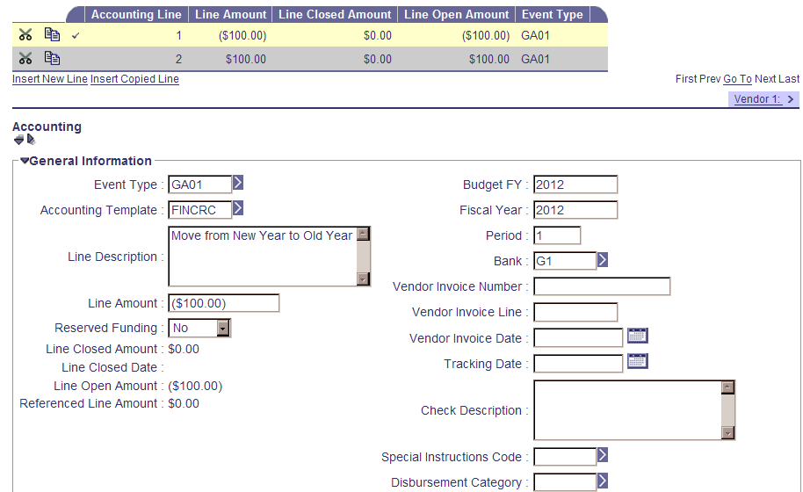

-Continued-

Accounting Line 2 shows a positive $100.00 and the 2011 Fiscal Period BFY=2011; FY=2011; Period=13).

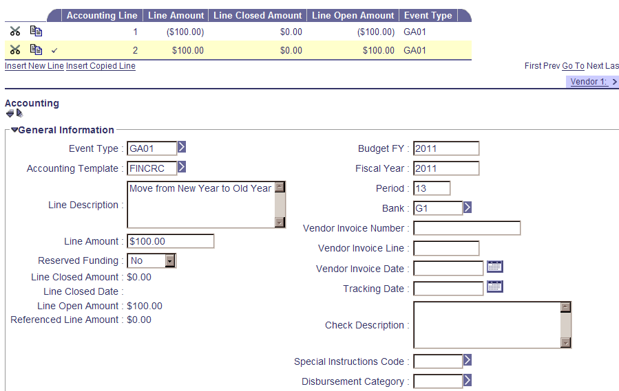

When processing JV2E documents during the fiscal year end, remember the
following:
- JV2Es to move expenditures between BFYs require the Fiscal Period (BFY, FY, and Period) to be entered on the Accounting Line.
- JV2Es with BFY 2011 reference may be processed within the department up to COB (7:00 p.m.),
July 8.
- JV2Es with BFY 2011 reference processed between July 9 and July 15 will require approval by the Office of the Controller, Statewide Accounting Services.


Fixed Assets Update

Property Officers, if you have not already submitted your FY 2011 Physical Inventory Observation reports to the Office of the Controller, please send them to Jennie Wolfe as soon as possible. They are due by the COB Thursday, May 26, 2011.

Real Property Closing Packages will be distributed around mid-August. The cover letter will include the due date the packet is due back to the Office of the Controller.

Please begin cleaning up your Fixed Assets shells. If possible, submit the shells. If the shells cannot be used, be sure to appropriately enter documents from scratch to record those fixed assets in eMARS. The target date for having all fixed assets shells, $5,000 and above processed is Sept. 1, 2011.


New Year Table Initialization (NYTI) Process

On Thursday May 5, 2011, the Office of the Controller ran the New Year Table Initialization (NYTI) process in eMARS. This process copied all active records on all tables keyed by Fiscal Year from the current Fiscal Year (2011) to the new Fiscal Year (2012). Fiscal Officers should review all agency maintained tables (primarily departmental Chart of Accounts (COA) tables) to ensure the active 2012 records are valid.

As part of this process, the Effective To and From dates will be cleared on the 2012 records. Therefore, if your agency uses these dates for a functional purpose, you will need to update the 2012 record on the appropriate table with the dates. Please be aware, if you intend for these records to be effective from July 1, 2011 to June 30, 2012, you do NOT need to update.

In addition, any new 2011 records entered after May 5, 2011 will also need to be entered as a 2012 record if applicable.

If you have any questions concerning this process, please contact the Customer Resource Center at Finance.CRCGroup@ky.gov or via phone at 502.564.9641 (Toll-Free 877.973.4357).


eMARS Training Hiatus

Traditionally, during fiscal year end, the Customer Resource Center (CRC) does not offer eMARS training, allowing agency and CRC staff to devote their time to fiscal year-end activities. During this break in training, CRC staff will also be working to update the training environments to include Fiscal Year 2012 information. We anticipate eMARS training to resume in mid July. However, if your agency has critical eMARS training needs during this time period, contact Donna Hall at 564-9641 ext. 459.

The eMARS End-User Training Schedule posted on the eMARS Web site at http://finance.ky.gov/internal/eMARS/training_resources.htm will be updated as classes are scheduled. As always, CRC thanks you for your cooperation and understanding.


eMARS Schedule on Furlough Weekends
FURLOUGH

Currently, the next set furlough day for all “state Executive Branch Merit and Non-Merit employees, including the Governor and all cabinet secretaries” is Friday, May 27, 2011. The full eMARS nightly cycle schedule will not be initiated. Reimbursement Output, which normally runs Friday nights will be run on Thursday evening, May 26 and include transactions from the previous Saturday through Thursday. As with most other holiday weekends, eMARS will be up and operational unless otherwise noted on the eMARS News and Alerts Web page available on the eMARS Web site at http://finance.ky.gov/internal/eMARS/. However, jobs that create interface documents, disbursements and update infoAdvantage will not run until close of business on the first business day following the furlough weekend (Tuesday, May 31, 2011).

Users should also be aware that the Office of the State Budget Director, the Office of the Controller, including the Office of Statewide Accounting Services, Office of Procurement Services, and the Customer Resource Center, will be closed on Friday, May 27 along with other state agencies.

For more information on eMARS, please refer to the eMARS Web site @ http://finance.ky.gov/internal/emars/

